**FTCC**

**SURGICAL TECHNOLOGY PROGRAM**

**NEW STUDENT**

**WELCOME AND**

**ACCEPTANCE PACKET**

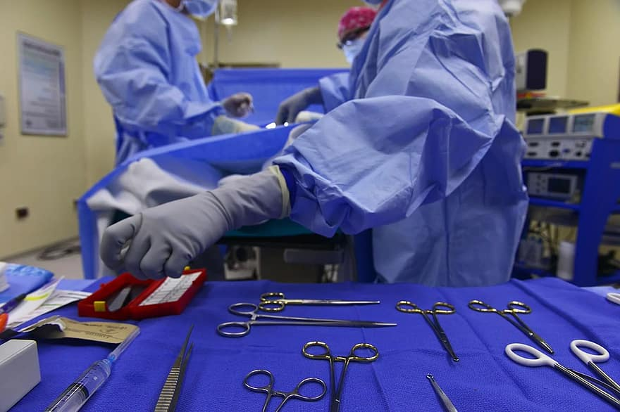

**“Aeger Primo……. The Patient First”**

**FTCC**

# Surgical Technology

Dear Surgical Technology Student:

# Congratulations!

On behalf of all the faculty and staff here at Fayetteville Technical Community College, I would like to say welcome and thank you for choosing Surgical Technology as your future degree program of choice. You have made an exciting and rewarding decision to learn and grow in this profession. At the completion of this program, you will be eligible to graduate and receive an Associate in Applied Science in Surgical Technology. Furthermore, you will be eligible to take the certification examination through the National Board of Surgical Technology and Surgical Assisting (NBSTSA).

It is critical that you review all of the information contained in your acceptance packet upon acceptance into this program. Your first day of class here at Fayetteville Technical Community College is extremely important. In class, we will discuss important departmental policies and procedures and you will also have an opportunity to ask any questions you may have. Attendance is extremely important. This program totals 5 semesters and intensity of coursework will vary.

You will get a detailed checklist with further information on each of the following, but the Program requirements that must be completed **PRIOR** to classes beginning in August include:

• Register for classes (Program Coordinator will assist)

• Purchase textbooks (through FTCC bookstore)

• Current CPR Certification (must be American Heart Association-BLS)

• Uniforms through Castle Uniforms

• Purchase of Rotation Manager to submit required documentation

(Background Check, Drug Screening, Immunizations, etc.)

As always, I am available if any questions arise. Please email me at [gallowas@faytechcc.edu](mailto:gallowas@faytechcc.edu) (preferred first choice) or via phone (910) 678-9861.



Sacha B. Galloway BS, CST, CSPDT

Program Coordinator – Surgical Technology

**FTCC SURGICAL SERVICES DEPARTMENT**  
SUR PROGRAM CHECKLIST

The following items must be completed prior to the first day of class, unless otherwise noted. These items are **required** for the program and delays can place the student behind in participation in classroom, laboratory, or clinical activities. Please initial beside each item upon completion and sign at the bottom once all items are ready for review. After accepting your seat, you may complete the checklist in any order to complete. Checklist must be completed by the end of Week 1 of classes and returned/signed to Program Coordinator.

1. Student has officially accepted their seat into the SUR Program.
2. Student has been registered for classes (Mrs. Galloway can assist with this).

1. Purchase Rotation Manager (includes Background check, drug screen, and required program documentation).
2. Complete Background check and drug screening in a timely manner.

1. Completed all required immunizations and upload into Rotation Manager (make sure to check requirements, as some have a time limit or require multiple doses or blood titers to show immunity). **All immunizations must be up to date and will not expire prior to completion of the program.**
   1. Hepatis B Series – Blood titer for Hepatitis B may be required at some facilities in addition to the 3-shot series. Please check with your provider or health department on costs of this test.
   2. Influenza – Current season only will be accepted (Aug-April).
   3. MMR – 2 Vaccinations or positive blood titer.
   4. T-dap – (Tetanus) Must be within 10 years or booster must be received.
   5. Varicella (Chicken Pox) – 2 Vaccines or positive blood titer.
   6. TB Skin Test – Performed annually; 2 PPD/TB Skin Tests are required for some clinical sites and all students must complete.
   7. COVID-19 Vaccine (Optional/Not required at this time)
2. Copy of BCLS (CPR) from American Heart Association only. Must state “Healthcare Provider and BLS” on the certificate. Upload into Rotation Manager and provide a copy to instructor. 2 years from issue and must not expire prior to completion of the program.
3. Order uniforms from Castle Uniforms. Order form and online instructions are included in your Student Acceptance Package.

1. Purchase textbook bundles through FTCC Bookstore. If using Financial Aid, be sure to check Self-Service for award letter and charging dates to ensure books are available prior to classes beginning.
2. Purchase of Medical Malpractice Insurance through the Cashier’s office and upload receipt into Rotation Manager (can do this the first week of classes).
3. Completed Physical Form. Document is available through Rotation Manager (also included in this packet) and must be completed within the last 6 months. This form is the **ONLY** one accepted. No other physical form will be accepted.
4. Code of Conduct – Rotation Manager; print, sign, and upload back into portal (also included in this packet).
5. Student Handbook Acknowledgement (given first day of class); review, sign, and uploaded into portal.
6. Acknowledgment of Program Policies (7 total) (given first day of class)
   1. Turned into Instructor upon review
   2. Policies are as follows:
      1. Job-related Requirements
      2. Background and Drug Screen
      3. Electronic Usage
      4. Cheating
      5. Confidentiality and Consent to Video/Photograph
      6. Pregnancy
      7. Equipment Agreement (if applicable)

______ 16. Logged into Blackboard on the first day of class and located the syllabi.

1. Program Orientation/Rules and Expectations first day of class.

I, ____________________________ (printed name), have completed all of the above requirements in a timely manner and verify that all information provided is correct to the best of my knowledge. I understand that by signing, I am aware that any missing items will need to be addressed and corrected immediately to continue in the Surgical Technology Program.

Student Signature: ______________________________________________________

Date: ____________________________

Program Coordinator: Sacha B. Galloway, BS, CST, CSPD-T

Signature: _____________________________________

Code of Conduct Statement

I acknowledge as a Health Program Student that I will adhere to the college’s “Student Code of Conduct” as outlined in the “Student Rights, Responsibilities and Judicial Process” in the FTCC Student Handbook.

**Student Signature________________________________Date____________________**

**Student Name**: __________________ **DATATEL ID**: ______________

Pre-Entrance Health Declaration

**EVALUATION and ASSESSMENT:** Evaluation and assessment require physical exam by a

healthcare provider.

**Based on my evaluation & assessment of this student’s physical and emotional health on**___________**, he/she appears able to participate in the activities of a health profession in a clinical setting.**

**YES_____ NO_____**

**___________________________________________________ ________________________**

**Signature of Physician/Physician Assistant/Nurse Practitioner Date**

**__________________________________________________ _________________________**

**Print Name of Physician/Physician Assistant/Nurse Practitioner Area Code/Phone Number**

**___________________________________________________________________________**

**Office Address City State Zip Code**

Rotation Manger

<https://rotationmanager.com/app/signup/index/home>

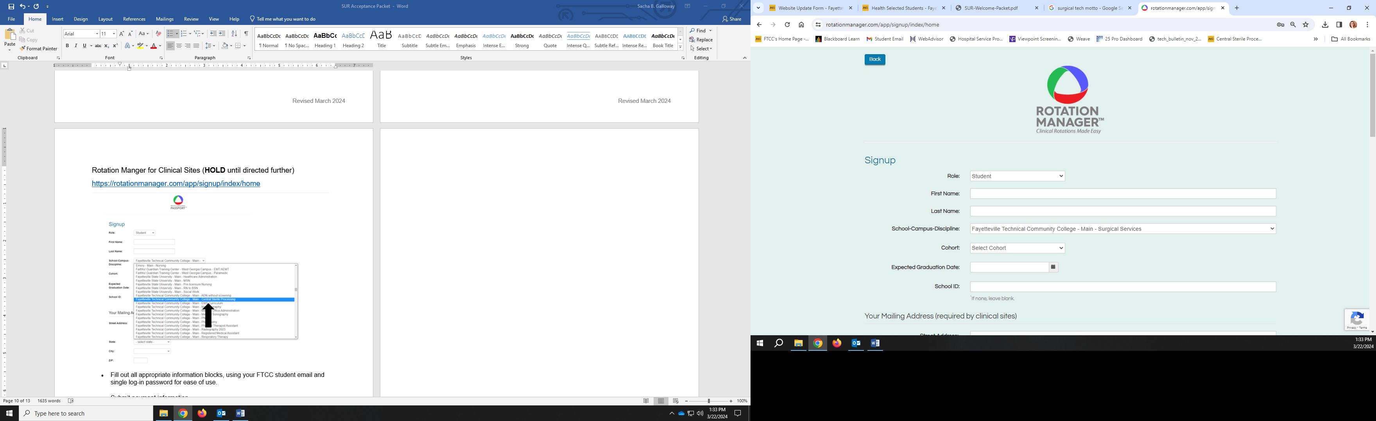

* Fill out all appropriate information blocks, using your FTCC student email and single log-in password for ease of use.
* Submit payment information.
  + Price: Your will be charged **$192.92** today for 24 months of coverage.
  + **NOTE:** Students **MUST** close their accounts at completion of program to avoid reoccurring payment charge of $54.99 renewal fee.

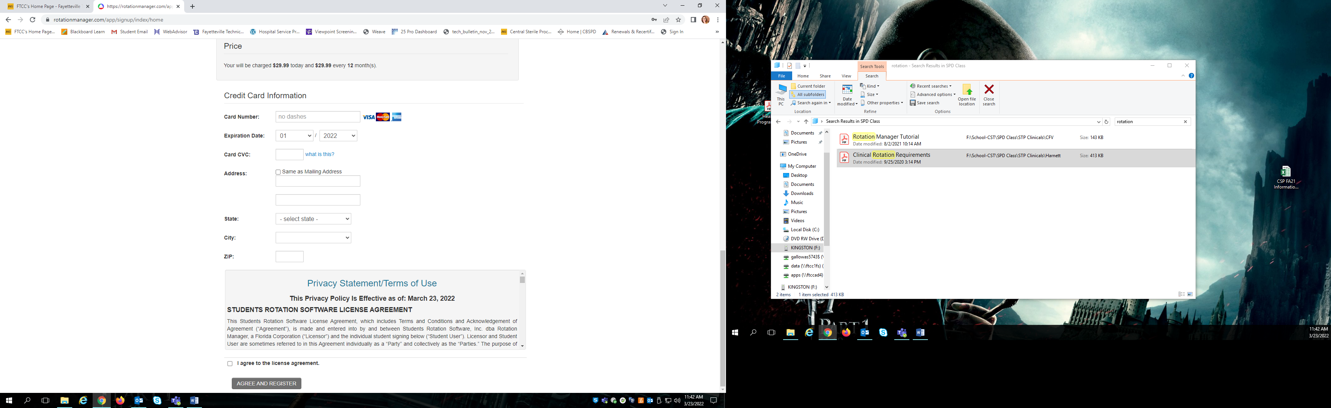

* Once registered, please complete all program and clinical requirements checklist under “School Files”



Welcome to Castle Uniforms and Welcome to the Healthcare Profession.

Congratulations on your acceptance to **Fayetteville Technical Community College Surgical Technology Program**.  It is a privilege to represent the healthcare profession. Healthcare students are ambassadors for their school. As a student, you will work with the public, patients, and many types of medical and healthcare personnel. It is imperative that you are easily identified.

Your uniform identifies you as part of this privileged, entrusted group. Castle Uniforms, a North Carolina based, family run business since 1969, will offer you a student discount as you transition into this profession associated with integrity, honesty and empathy. The estimated cost of your required uniform package is $150.00 depending on items added to your customized student package.

We look forward to helping you with your uniforms, shoes and diagnostic tools. We have options for you:

* ***In-store fittings***- group sales consultants are available to assist you Monday – Saturday from 10 AM to 6 PM at Castle Uniforms, 1800 Skibo Road #228, Cross Creek Plaza, Fayetteville, North Carolina 28303.
* ***Online Ordering-*** please visit [www.shopcastleuniforms.com](http://www.shopcastleuniforms.com) and use the sign in code **FTCCST25** to access the ordering site for FTCC Surgical Tech.
* **Please allow *6-8 weeks delivery* time for student uniform packages. Please order by June 30th, 2025**
* ***Personal Shopping Account***- before ordering, please visit [www.castleuniforms.com](http://www.shopcastleuniforms.com/) and click on Create Personal Profile, located at the top to establish your student account and assure accuracy of shipping address. If you have shopped with us before, phone or email us for your account number to link to your existing account.

**Payment Information**

* Pre- payment is required on your custom student package at time of placing the order.
* Castle Uniforms will work with approved 3rd party billing agencies.
* Students using Financial aid via the FTCC Bookstore need to come in and begin the ordering process this summer. Bookstore orders will not be available for pickup until they have been approved by FTCC.

**Optional diagnostic tools, shoes, stethoscopes and socks available at student discount**

* Shoes-appropriate shoes may include closed toe, closed heel, supportive for standing on your feet all day and made of materials that will not allow body fluids to absorb.
* Socks-graduated compression that forces blood and fluid flow back up your legs

We look forward to dressing you in your journey to help others in your medical profession.

Sincerely,

Castle Uniforms

[sales@castleuniforms.com](mailto:sales@castleuniforms.com)

1800 Skibo Road # 228 Cross Creek Plaza Fayetteville, NC 28303 p. 910-485-4429 f. 910-485-1825



**2025**

CPR: BLS for Healthcare Providers through American Heart Association

Options Available:

1. Instructor: Larry Epler
   * [lmepler@yahoo.com](mailto:lmepler@yahoo.com) or 910-624-5436 to get dates/times and to set up appointment
     1. Let him know you are a FTCC Surgical Tech student
   * $55 cash
   * Saturdays 10 – 2 pm at Northwood Temple Academy
2. FTCC Continuing Education
   * Registration information 910-678-8386 Neill Currie Building (Room 2) or online
   * 5-hour class
   * $45
   * Call for available course dates

Note: CPR cannot expire prior to completion of the program and must be renewed in a timely manner.