**FAYETTEVILLE TECHNICAL COMMUNITY COLLEGE**

PO BOX 35236 * FAYETTEVILLE, NORTH CAROLINA 28303-0236 * PHONE: (910) 678-8400 * FAX: (910) 678-6600

(Academic Year: 2025-2026)

Dear Speech-Language Pathology Assistant Student:

Congratulations on your acceptance to the Speech-Language Pathology Assistant Program! This program is one of only two SLP-Assistant Programs in North Carolina. I am happy that you chose to join the elite group of people who have taken this journey before you. Classes begin Monday, August 18, 2025. If you have not registered and require assistance, please call, or email me, as soon as possible, as courses will fill quickly. You should register for SLP 111, SLP 140, and BIO 163 (if you have not already completed BIO 163 or BIO 168/169). If you have already successfully completed BIO 163 with a grade of “B” or better and need to complete one of the other general education courses, you may register for that additional course, as well.

Completing the tasks on the following list will help you get started in the SLP-Assistant Program:

1. Register for Classes.
2. Create an account with Viewpoint Screening and upload your medical form and updated immunizations. You can find the necessary information at <https://www.viewpointscreening.com/faytechcc>.
3. Purchase FTCC Liability Insurance for the Fall Semester in August.
4. Complete American Heart Association CPR Certification for the Healthcare Provider.
5. Purchase your name tag.
6. Complete the required (5) Pre-Entry Observation hours.

Attendance on the first day of class is particularly important! During this session, new students will receive a comprehensive overview of the Speech-Language Pathology Assistant Program. **Our SLPA Program Orientation will take place on Monday, August 18, 2025 at 1:00PM in the SLPA Lab located in the Health Technology Center Rm. 141.** **Each first-year student is required to attend. In other words, this session is mandatory, so please make the proper arrangements to attend.**

I may be reached at [gaineyc@faytechcc.edu](mailto:gaineyc@faytechcc.edu) or (910) 678-8492.

Sincerely,

Charisse N. Gainey

Charisse N. Gainey, M.ED., CCC-SLP

Department Chairperson, SLP-Assistant Program

[gaineyc@faytechcc.edu](mailto:gaineyc@faytechcc.edu)

(910) 678-8492



**FAYETTEVILLE TECHNICAL COMMUNITY COLLEGE**

PO BOX 35236 * FAYETTEVILLE, NORTH CAROLINA 28303-0236 * PHONE: (910) 678-8400 * FAX: (910) 678-6600

**Speech-Language Pathology Assistant Program Check List**

* Register for Required Courses
* Complete (5) pre-entry observations
* Viewpoint Screening Requirements
* Immunizations
  + - * Measles, Mumps & Rubella (MMR) – 2 vaccines or positive titer
      * Varicella (Chicken Pox) – 2 vaccines or positive titer
      * Hepatitis B (HepB) – 3 vaccines or positive titer
      * Tuberculosis (TB) – 1 TB Skin test: annual renewal)
      * Tetanus, Diphtheria, & Pertussis (Tdap) – administered within the last 10 years: renew every 10 years)
      * Influenza (Flu) - administered September to March: annual renewal)
* Physical Examination
* CPR Certification
* SpeechPathology.com Educational Access Videos
  + - * HIPAA Videos
      * Preventing Bloodborne Pathogens
* Handbook Acknowledgement (after orientation)
* Code of Conduct Statement
* Professional Liability Insurance

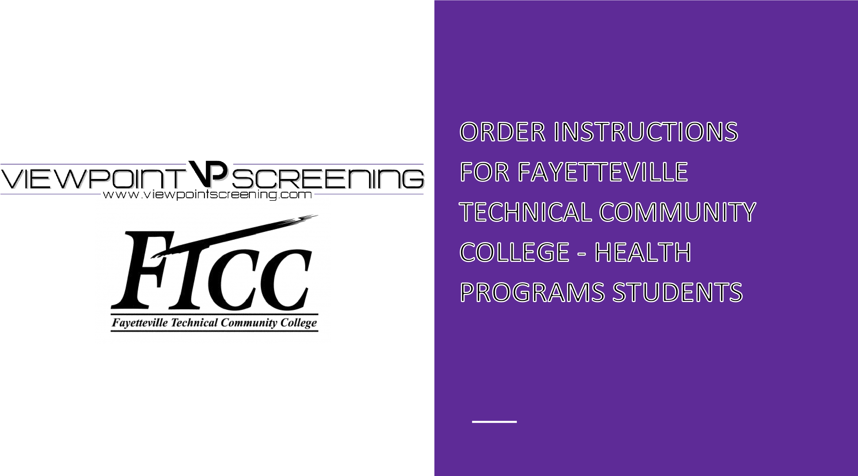

|  |  |
| --- | --- |
| **Start Your Order**  To get started:  Visit <https://www.viewpointscreening.com/faytechcc>and click on "Start Your Order".   * Select your program and package option * Enter your information (name, dob, etc.)   **\*\*\*Important\*\*\*** Please make sure you are entering your correct email address.  You will be unable to log in or receive communications from Viewpoint Screening if  your email address is not valid.  Once your order is submitted, you will receive a confirmation email containing a  password. Use this info to log into your account to review other instructions you may  have. You will also need this password to view your background check report.  **Drug Test** - You will receive an email with the subject line: “Viewpoint Screening Drug-screen  registration” within 24-48 hours. This email will contain instructions and explain where you  need to go to complete your drug test. |  |

**Health Portal**

**You will have the capability to upload specific** **documents required by your school** forimmunization**,** medicalorcertificationrecords.

* After you have placed your initial order, you will begin to get emails that notify you of additional items you need to take care of that are required by your school for clinical placement.
* To see the list of required immunizations and documents, after you have placed your order, go to[:](https://www.viewpointscreening.com/) [viewpointscreening.com](https://viewpointscreening.com/) [an](https://www.viewpointscreening.com/)d click on LOG IN in the right corner; use your email and password to log in.
* When logged in, click on **Health Portal** to view your specific requirements. Click on the **Question Mark** to expand the requirement and view the details of what is acceptable. Be sure to read these thoroughly, so you know what kind of documents you will need.
* As you complete your requirements, you can begin to upload them into your account at any time.
* To associate a document with a requirement: Click on the “Upload Document” button next to each requirement and select the correct file to upload. This can be done on a desktop computer, tablet or smartphone. All uploaded documents are typically reviewed within 24

hours. If your document is not compliant, you will receive an email

notifying you why it was not compliant, and how to fix it. This information can also be found in the “Student Messages” section of your account.

* You will receive weekly email reminders to upload required documents, and you will be notified 30 days in advanced when a document is about to expire.

# SAMPLE

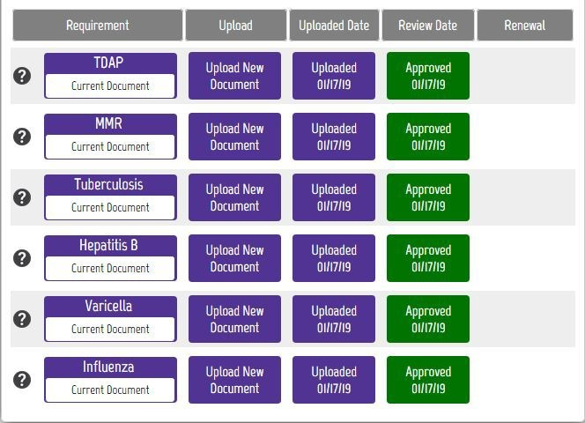

FOR BEST RESULTS:

DO: Be sure your name is visible on the document you upload. If your name is not on the document, it will be denied, and you’ll have to upload it again.

DO: Make sure you uploaded the correct document for a particular requirement.

DO: Be sure to read what is acceptable. For example, receipts are not acceptable as proof of influenza vaccination.

DO: Make sure document is not expired and will not expire during your clinical rotation.

**If you have any additional questions, please contact Viewpoint Screening via email at:** [**studentsupport@viewpointscreening.com**](mailto:studentsupport@viewpointscreening.com)**.**

**Or use the instant chat feature at** [**viewpointscreening.com.**](https://viewpointscreening.com/) **We are pleased to help you with this process!**



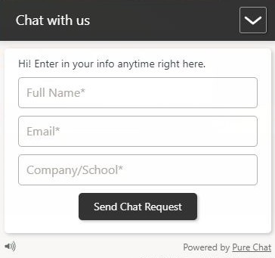

**List of Requirements and Necessary Items**

# Standard for Every Health Program

## Measles, Mumps and Rubella (MMR)

Submit documentation of one of the following:

2 Vaccines

Positive antibody titer (lab report required)

If your titer is negative or equivocal, new alerts will be created for you to repeat the vaccination series (2 vaccines administered after your titer).

If your series is in process, submit where you are in the series, and new alerts will be created for you to complete the process.

## Varicella

Submit documentation of one of the following:

2 Vaccines

Positive antibody titer (lab report required).

If your titer is negative or equivocal, new alerts will be created for you to repeat the vaccination series (2 vaccines administered after your titer).

If your series is in process, submit where you are in the series, and new alerts will be created for you to complete the process.

## Hepatitis B

Submit documentation of one of the following:

3 Vaccines

Positive antibody titer (lab report required).

If your titer is negative or equivocal, new alerts will be created for you to repeat the vaccination series (3 vaccines administered after your titer).

If your series is in process, submit where you are in the series, and new alerts will be created for you to complete the process.

## Tuberculosis

Submit documentation of one of the following:

1-Step TB skin test

If positive results, submit physician clearance documented on letterhead.

The renewal date will be set for 1 year. Upon renewal, one of the following is required:

1-Step TB skin test

If positive results, submit physician clearance documented on letterhead.

* Some facilities require a 2-Step TB test. Please follow instructions accordingly. *

**\*\*Note\*\*** If you have history of positive TB results you will need a licensed medical professional to complete the N.C. Department of Health and Human Health Services form #3405, “Record of Tuberculosis Screening” and upload.

## Tetanus, Diphtheria, and Pertussis (Tdap)

Submit documentation of a Tetanus, Diphtheria, & Pertussis (Tdap) vaccination, administered within the past 10 Years.

The renewal date will be set for 10 years from the date administered

If your documentation lists multiple Tetanus vaccinations on one line (e.g. Tetanus/DTP/DTaP/Td/Tdap), ensure that your physician indicates which shot was administered on each date listed.

*New DHHS recommendation being adhered to by the Health Department: any recent TD immunizations will receive the TD booster. *

## Influenza

Submit documentation of one of the following:

Influenza vaccination administered during the current flu season (September - March).

Declination signed by a healthcare provider.

The renewal date will be set for 1 year.

## Physical Examination

Download, print, complete, and re-submit the 1-page physical exam form.

Documentation must be signed by a medical professional and be dated within the past 6 months.

## Drug Screen and Background Check

Follow the steps by Viewpoint to go to appropriate testing facility.

Submit any necessary documents and complete any steps for background check.

## CPR Certification

Submit documentation of your current CPR certification.

Documentation must be directly from the American Heart Association (AHA) and must be the Basic Life Support (BLS). The AHA distributes electronic completion cards. This can be directly uploaded. If you received an actual card, make sure to sign the card and submit a copy of both side; front and back.

The renewal will be set based on the expiration of your current certification.

## HIPAA and Preventing Bloodborne Infections

Some programs require that you watch three modules for HIPAA and three modules for the Bloodborne Pathogens. At the completion of each module, you will save your completion certificate and then upload it to corresponding name of the certificate. You will have six certificates. Make sure to upload them to their individual module. For example, you should upload the “HIPAA for Healthcare Workers: The Privacy Rule” to its corresponding standard in the Medical Document Tracker.

Some programs train their students within their program. Ensure you read the appropriate standards on Viewpoint Screening for the individual Program and ask any questions to the Department Chair or Program Chair/Coordinator for clarification.

## Handbook Acknowledgment

After acceptance into your Health Program of interest, you will be given a handbook for that program. You will read the handbook, then sign the appropriate form. Prior to upload, ensure the Department Chair or Program Chair/Coordinator does not require their signature as well to meet this requirement. Once completed to the Program Chair/Coordinator’s standards, you will then upload the signed document.

## Code of Conduct

After review of the “Student Code of Conduct” as discussed in the “Student Rights, Responsibilities and Judicial Process” in the FTCC Student Handbook, you will click “Confirm” in acknowledgement that you understand and will agree to adhere to these expectations.

## Professional Liability Insurance

You will purchase medical liability on campus from the Cashier’s Office. There are two locations- in the Tony Rand Student Center and in the Thomas McLean Administration Building. You will upload your receipt for this purchase in this section to complete this requirement.

# Special Requirements- Professional License

## Mammography

You are required to be a registered radiologic technologist prior to beginning mammography. You will need upload a copy of your current American Registry of Radiologic Technologist’s card.

## Associate Degree Nursing (RN)

You are required to be licensed as a Certified Nursing Aide I or Licensed Practical Nurse. You will need to upload your current card of one these certifications.

**HIPAA and Bloodborne Infections Review Modules**

SpeechPathology.com Educational Access

# Register for the Educational Access (free membership):

1. Visit SpeechPathology.com/eduaccess, then click the red Get Started button.
2. Create your account.
3. At the payment information screen, accept the terms and click Submit Payment. (If you are prompted for a promo code, enter EDUACCESS).

# Watch the following videos and complete the assessments:

1. (9889) or (1033794) Occupational Safety and Health Administration (OSHA) Bloodborne Pathogens Standards: What You Need to Know Presented by Kathleen Weissberg, OTD, OTR/L
2. (10091) or (1033816) HIPAA for Allied Health Professionals Presented by Kim Cavitt, AuD

*You will be able to access your certificate of completion after you complete the brief quiz.

*Save each certificate and upload it to your ViewPoint Screening account.