Dear Radiography Student,

Welcome to the Radiography Program at Fayetteville Technical Community College! We hope you are looking forward to a challenging career choice!

Orientation for the Radiography Program is required and will be held from 8:30 a.m. to 3:30 p.m. on June 11, 2025, in the Health Technology Center, Room 111**. You must attend this session or forfeit your slot in the program**. There will be many items distributed and policies and procedures will be reviewed at that time. There are no make-up dates for orientation, plan accordingly.

In order for you to be ready for the fall semester, the list below contains just a few of the things that will be discussed:

1. Registration – Your registration will be discussed with you at orientation for the first semester. The first semester RAD courses are a total of ten credit hours. You need to update your **residency information** before you attend orientation.
2. Bring your own laptop if you prefer to work on your own laptop. We can get laptops for you to use, but if you like yours best, bring it along.
3. Uniforms – Uniform information is included in this packet. It is possible to pay a deposit and make payments throughout the summer. Your order is due no later than **June 30th**.
4. Radiographic identification markers must be ordered and received prior to the start of the curriculum. These markers are needed in RAD 111, RAD 113 and RAD 151 on the **first day** of the course. The markers take approximately 3-4 weeks to be manufactured, so you cannot wait to order. The ordering information is included in this packet. You will need to order **two or three sets** of the specified markers when placing your order. You must **not** order other colors or options. You must order your initials – first, middle and last name. The information is included in this packet. Please type in the actual item number to ensure you order the correct markers. These should be completely metal markers.
5. CPR certification and immunizations – Immunizations and CPR documentation will be uploaded to a website. We will discuss this process at orientation.
6. Background checks and drug screens – All students are required to complete a criminal background check and drug screen prior to attending clinical rotations. The information you need will be given to you at the orientation session. You need to be prepared to purchase the items needed on the day of orientation. Please bring your appropriate credit cards with you on that day.
7. We look forward to seeing you on June 11, 2025 at 8:30 a.m. Also, be reminded that you cannot bring children with you to campus or any significant others.

You may contact this office at the e-mail address or phone number given below if you have additional questions or concerns. On behalf of the faculty for the Radiography Program, we welcome you!

Sincerely,



Anita L. McKnight, M.S. Ed. RT(R)

Radiography Department Chair

(910)678-8303

E-mail: [mcknigha@faytechcc.edu](mailto:mcknigha@faytechcc.edu)

**Penn-Jersey X-Ray Markers**

**Each hyperlink below will take you to the correct page for your markers:**

Order two sets of markers with the Right and Left and 3 initials. You must have these on the first day of class.

***We suggest three sets so that you always have a back-up set. If you don’t have a middle initial, choose one.***

Top of Form

[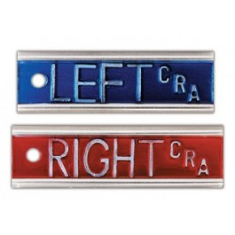](http://pjxray.com/media/catalog/product/cache/1/image/400x400/9df78eab33525d08d6e5fb8d27136e95/2/e/2e_2_.jpg)

**X-Ray Markers with Initials Right & Left**  
Item #: LMTA-2E

Price: $26.00

https://pjxray.com/catalogsearch/result/?q=+LMTA-2E

Top of Form

[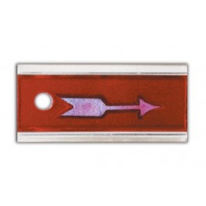](http://pjxray.com/media/catalog/product/cache/1/image/400x400/9df78eab33525d08d6e5fb8d27136e95/l/m/lm-ea.jpg)

**Aluminum Elite Arrow Marker**  
Item #: LM-EA

Price: $9.50

https://pjxray.com/aluminum-elite-arrow-marker.html