FAYETTEVILLE TECHNICAL COMMUNITY COLLEGE **PHYSICAL THERAPIST ASSISTANT PROGRAM** MEMORANDUM

To: Incoming Class

From: Annette Webster, DHSC, MBA, PTA Carmel Herrin, PT, M

TOPIC: **CONGRATULATIONS**

We are pleased you have accepted admission into the PTA Program. While many applied for the program, you were among those who met the academic criteria required for our program. There are no additional requirements for entry into the PTA Program. Your acceptance into the Physical Therapist Assistant Program is subject to the following conditions:

1. You must maintain a major grade point average of 2.5 or above and a cumulative grade point average of 2.0 or above before entering the Physical Therapist Assistant Program.
2. Once you enter the Physical Therapist Assistant Program, you are subject to the rules and regulations of the Physical Therapist Assistant Program.

Before entrance into the Physical Therapist Assistant Program, you must fulfill certain obligations:

1. **Register for fall classes (PTA 110 and PTA 130)**
2. **Current CPR Certification (American Heart Association**, **BLS Provider with AED)**
3. **Purchase and submit program requirements using** [**View Point Screening**](https://www.viewpointscreening.com/faytechcc) **(Immunizations, physical, view HIPAA and BBP videos (eLearning), Code of conduct, CPR. * Flu immunization will not be available until the fall semester- Do NOT get flu vaccine in the summer)**
4. **Required uniforms must be purchased (2 polo shirts with FTCC PTA Program logo, and name tag- first name and last initial)**
5. **Attend orientation: date, time and location to be determined.**

Congratulations, again on behalf of the entire PTA Program faculty, on your acceptance into the Physical Therapist Assistant Program at Fayetteville Technical Community College. If you decide not to pursue the program this fall please notify me as soon as possible through email [webstera@faytechcc.edu](mailto:webstera@faytechcc.edu)), so we are able to offer that position to another applicant.

We look forward to seeing you in August. If you have any questions or concerns over the summer, please call or email me

Mrs. Carmel Herrin, PT, DCE & Dr. Annette Webster, PTA, Program Director herrinc@faytechccedu webstera@faytechcc.edu

Welcome to Castle Uniforms and Welcome to the Healthcare Profession.

Congratulations on your acceptance to **the Fayetteville Technical Community College Physical Therapy Assistant Program.** It is a privilege to represent the healthcare profession, and healthcare students are ambassadors for their school. As a student, you will work with the public, patients, and many medical and healthcare personnel. You must be easily identified.

Your uniform identifies you as part of this privileged, entrusted group. Castle Uniforms, a North Carolina-based, family-run business since 1969, will offer you a student discount as you transition into this profession associated with integrity, honesty, and empathy. Your required uniform package is estimated at $65.00 to $100.00, depending on the items added to your customized student package.

We look forward to helping you with your uniforms, shoes, and diagnostic tools. We have options for you:

* ***In-store fittings***—group sales consultants are available to assist you Monday through Saturday from 10 AM to 6 PM at Castle Uniforms, 1800 Skibo Road #228, Cross Creek Plaza, Fayetteville, North Carolina 28303.
* ***Online Ordering: Please visit www.shopcastleuniforms.com and use the sign-in*** code **FTCCPTA24** to access the ordering site for FTCC PTA.
* **Please allow *6-8 weeks delivery* time for student uniform packages. Please order by June 30th, 2023**
* ***Personal Shopping Account***—Before ordering, please visit www.castleuniforms.com and click on Create Personal Profile at the top to establish your student account and ensure the accuracy of the shipping address. If you have shopped with us, phone or email us for your account number to link to your existing account.

**Payment Information**

* Pre-payment is required on your custom student package at the time of placing the order.
* Castle Uniforms will work with approved 3rd party billing agencies.
* Students using financial aid via the FTCC Bookstore need to come in and begin the ordering process this summer. Bookstore orders will not be available for pickup until FTCC has approved them.

**Optional diagnostic tools, shoes, stethoscopes, and socks are available at student discount**

* Shoes-appropriate shoes may include closed-toe, closed-heel, supportive for standing on your feet all day, and made of materials that will not allow body fluids to absorb.
* Socks-graduated compression that forces blood and fluid flow back up your legs

We look forward to dressing you in your journey to help others in your medical profession.

Sincerely,

Castle Uniforms,

1800 Skibo Road # 228 Cross Creek Plaza Fayetteville, NC 28303 p. 910-485-4429 f. 910-485-1825

|  |  |  |  |  |  |  |  |
| --- | --- | --- | --- | --- | --- | --- | --- |
| SO#______________ | | | **Castle Uniforms**  [www.castleuniforms.com](http://www.castleuniforms.com/) | | | # _______ | |
| 1800 Skibo Road, Suite 228, Raeford Road, Fayetteville, NC 28303  (phone) 910-485-4429 (fax) 910-485-1825 | | | | | | | |
| **FTCC PTA PROGRAM 2023** | | | | | | | |
| First___________________________________MI_____Last______________________________________ | | | | | | |  |
| Address_________________________________________________________________________________ | | | | | | |  |
| City__________________________________________________State______Zip______________________ | | | | | | |  |
| Mobile #________________________________E-Mail_________________________________ | | | | | | |  |
| **Requirements** | | | | | | | |
| 1st Year Students: 2 Polos (any color) with the FTCC PTA School Logo, 1 Set of Nametags | | | | | | | |
| 2nd Year Students: Will Need Style/Color Scrub | | | | | | | |
| *Students Can Wear Clean Tennis Shoes* Students Can Also Wear Any Color Coordinating Long Sleeve Under scrub* | | | | | | | |
| **Please Create Your Student Account at www.castleuniforms.com!** | | | | | | | |
| **PAYMENT POLICY: - All orders must be paid in full before shipment to student. We accept MC, VISA, AMERICAN EXPRESS & MONEY ORDERS** | | | | | | | |
| **Packed** | **Qty** | **Size** | **Item** | **Description** | **Size** | **Unit Price** | **Total** |
|  | 1 |  | **NAMETAGS** | NAM-FTCC PTA |  | $15.00 |  |
|  |  |  |  |  |  |  |  |
|  |  |  |  | **Please Print First Name and Last Initial to Appear on Nametag** |  |  |  |
| **1st Year Students** | | | | | | | |
|  |  |  | **POLO**  **SHIRTS** | Polo Shirt with FTCC PTA Logo  *Color of your choice (Shirt and Thread color)*  *PRO FTCCPTA MULTI $8.00*  *Ladies Polo SM L500 and Men’s Polo SM K500*  *Logo Thread Color:*  *Polo 1 _______*  *Polo 2 _______* | XS-XL | $24.99 |  |
|  |  |  | 2X | $26.69 |  |
|  |  |  | 3X | $30.09 |  |
|  |  |  | 4X | $31.79 |  |
|  |  |  | 5X | $35.19 |  |
| **Packed** | **Qty** | **Size** | **Item** | **Description** | **Size** | **Unit Price** | **Total** |
|  |  |  | **PANTS** | *Optional Khaki, Navy or Black pants to wear with Polos* |  |  |  |
|  |  |  |  | *Prices Vary Depending on Style* |  |  |  |
| **2nd Year Students** | | | | | | | |
|  |  |  | **SCRUB**  **TOPS** | Color and Style of your choice  *not needed until second year* |  |  |  |
|  |  |  |  |  |  |
|  |  |  | **SCRUB**  **PANTS** | Color and Style of your choice  *not needed until second year* |  |  |  |
|  |  |  |  |  |  |
|  |  |  | **SHOES** | *Any Color-Closed toe/heel* |  |  |  |
|  |  |  | **SOCKS** | *Any Color- Compression Sock Recommended* |  |  |  |
|  |  |  |  |  |  |  |  |
|  |  |  |  |  |  | Subtotal |  |
| **Important Information: Please initial and sign.** | | | | |  | Tax 7% |  |
| ____Customized items must be paid in full. | | | | | | Total |  |
| ____1/2 Down deposit must be secured on remaining items. | | | | | | Deposit |  |
| ____Order must be paid in full to receive any part of the order. | | | | | | Due |  |
| ____Any cancellations made after 5 business days will result in a $15 restocking fee. | | | | | |  |  |
| ____$10 processing fee for all outsourced billing. | | | | | |  |  |
| ____No refunds or exchanges on customized items. | | | | | |  |  |
| **SIGNATURE REQUIRED/ORDER APPROVAL:** | | | | **Date** |  |  |  |

Physical Therapist Assistant Program

✓ Check List

Order Uniform

* + Viewpoint Requirements
  + Immunizations

Measles (Rubeola), Mumps & Rubella (MMR): 2 Vaccines or Positive titer

Varicella (Chicken Pox): 2 Vaccines or Positive titer

Hepatitis B: 3 Vaccines **AND** Positive titer

Tuberculosis (TB)

Tetanus, Diphtheria & Pertussis (Tdap): Administered within the past 10 years

Influenza: Administered during the Fall 2024 semester

Covid-19 (recommended)

Physical Examination

CPR Certification

* + - eLearning

HIPAA

Preventing Bloodborne Infections

Handbook Acknowledgement (during first week of semester)

Code of Conduct Statement

Professional Liability Insurance (purchase at FTCC Business office during the first week of the semester)



**Start Your OrderTo get started:**

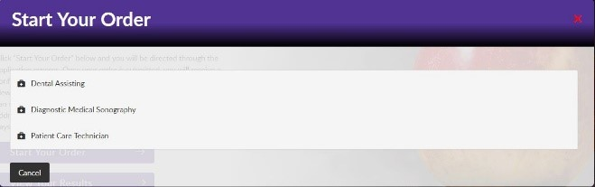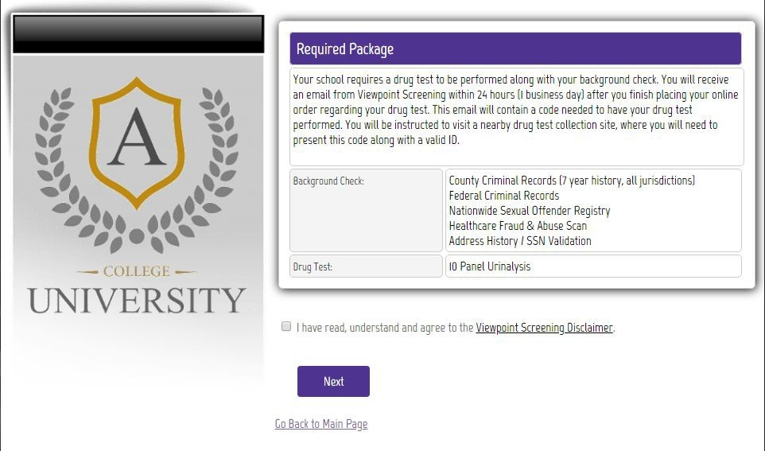

Visit <https://www.viewpointscreening.com/faytechcc> and click on “Start Your Order”

- Select your program and the Health Portal package option

- Enter your information (name, dob, etc.)

**\*\*\*Important\*\*\*** *Please make sure you are entering your correct email address. You will be unable to log in or receive communications from Viewpoint Screening if your email address is not valid.*

Once your order is submitted, you will receive a confirmation email containing a password. Use this info to log into your account to review other instructions you may have.

**If you wish to see a copy of your requirements prior to placing your order, you can click here:** [FTCC PTA Program Health Portal Requirements](https://www.viewpointscreening.com/healthportalManager-2?school=4139942)

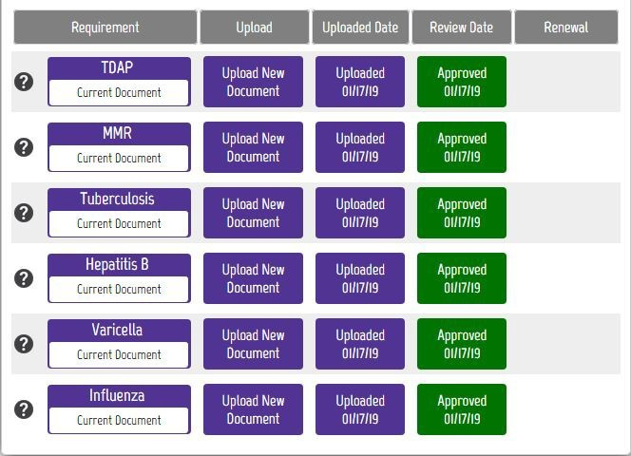

**SAMPLEHealth Portal**

**You will have the capability to upload specific documents required by your school for immunization, medical or certification records**.

● After you have placed your initial order, you will begin to get emails that notify you of additional items you need to take care of that are required

by your school for clinical placement.

● To see the list of required immunizations and documents, after you have placed your order, go to: [viewpointscreening.com](https://www.viewpointscreening.com/) and click on

LOG IN in the right corner; use your email and password to log in.

● When logged in, click on **Health Portal** to view your specific requirements. Click on the **Question Mark** to expand the requirement

and view the details of what is acceptable. Be sure to read these thoroughly, so you know what kind of documents you will need.

● As you complete your requirements, you can begin to upload them into

your account at any time.

● To associate a document with a requirement: Click on the “Upload Document” button next to each requirement and select the correct file

to upload. This can be done on a desktop computer, tablet or smartphone. All uploaded documents are typically reviewed within 24

hours. If your document is not compliant, you will receive an email notifying you why it was not compliant, and how to fix it. This

information can also be found in the “Student Messages” section of your account.

You will receive weekly email reminders to upload required documents, and you will be notified 30 days in advanced when a document is about to expire.

FOR BEST RESULTS:

DO: Be sure your name is visible on the document you upload. If your name is not on the document, it will be denied, and you’ll have to upload it again.

DO: Make sure you uploaded the correct document for a particular requirement.

DO: Be sure to read what is acceptable. For example, receipts are not acceptable as proof of influenza vaccination.

DO: Make sure document isn’t expired, and won’t expire during your clinical rotation.

**If you have any additional questions, please contact Viewpoint Screening via email at:** [**studentsupport@viewpointscreening.com**](mailto:studentsupport@viewpointscreening.com)**.**

**Or use the instant chat feature at** [**viewpointscreening.com.**](https://viewpointscreening.com/) **We are pleased to help you with this process!**

