

FAYETTEVILLE TECHNICAL COMMUNITY COLLEGE

P.O. BOX 35236 • FAYETTEVILLE, NORTH CAROLINA 28303-0236 • PHONE (910) 678-8400 • FAX (910) 678-6600

Memorandum

To: Pharmacy Technology Students

From: Dina Adams, Pharm.D., R.Ph.

Department Chair, Pharmacy Technology

Re: Pharmacy Technology Program Requirements

I am pleased to welcome you to the Pharmacy Technology Program. I know it is an exciting time for you as you begin preparation for your career as a pharmacy technician.

Your acceptance packet contains important information. I would encourage you to read each attachment to make sure you understand all that is required of you prior to entrance to the program.

I would encourage you to register for classes as soon as possible. Early registration increases your chances of getting the classes you want at the times you want. Be sure to follow the curriculum sequencing. You should register for PHM 110, PHM 111, PHM 115, and PHM 120. In addition, if you have not already taken MAT 110 (or MAT 143) and MED 120 you should register for those classes as well. Our curriculum is designed so that classes are taken in a proper sequence to ensure a smooth transition each semester.

Program requirements that must be completed prior to classes beginning are:

1. **Register for classes**
2. **Current CPR Certification (must be valid throughout program)**
3. **Purchase and submit program requirements using Viewpoint (Background Check, Drug Screen, Immunizations, etc.)**
4. **Required uniforms must be purchased**

The first day of class is extremely important. Departmental policies are discussed along with an orientation to the entire curriculum. Your attendance on this first day is very important.

I anticipate an exciting and productive year.

Pharmacy Technology Program

✓ Check List

Register for Required Courses

Order Uniform

* + Complete Viewpoint Requirements

Criminal Background Check

Drug Screen

HIPAA Training

Bloodborne Pathogen Training

* + Immunizations

Measles (Rubeola), Mumps & Rubella (MMR): 2 Vaccines or Positive titer

Varicella (Chicken Pox): 2 Vaccines or Positive titer

Hepatitis B: 3 Vaccines or Positive titer

Tuberculosis (TB)

Tetanus, Diphtheria & Pertussis (Tdap): Administered within the past 10 years

Influenza: Administered September – March

Physical Examination

CPR Certification

Handbook Acknowledgement (after orientation)

Code of Conduct Statement

Professional Liability Insurance

Castle Uniforms

1800 Skibo Road. Unit 228,

Fayetteville, NC 28303/

Phone 910-485-4429/Fax 910-485-1825/

M-F 10AM-5PM

FTCC Pharmacy Technology

REQUIREMENTS

2 Navy Blue tops with Logo

2 Navy Blue Pants

1 White Lab coat with Logo

1 Set of Nametags (2 in a set)

Special Instructions 1/2 deposit required to process order.

Students and Agencies must pay in full to receive shipment of any part of their order. Any cancellations made after 5 business days of original order date will receive a $15 restocking fee. There will be a $10 fee added to all orders requiring billing to agencies and bookstores to cover the costs for this process. It is the student's responsibility to provide us with the correct information on their sponsoring agencies. We cannot provide accurate ship dates on orders without payments. No refunds will be given on items that have been altered, worn, laundered, or customized with the student's name or school logo. For security reasons, payments must be paid by money order to the address above, or with a credit/debit card by clicking on the Student Payments link on our secure website's homepage. By supporting these conditions, you help us keep costs down so that we may continue to provide the lowest student prices possible. Thank you and good luck in school

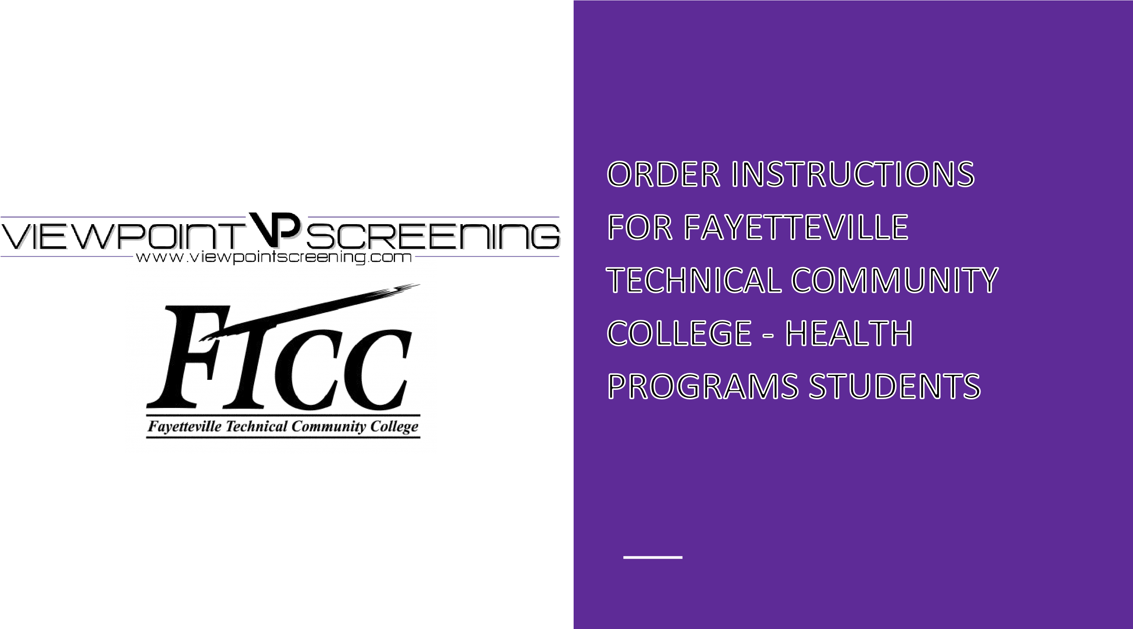

**Start Your Order**

To get started:

Visit <https://www.viewpointscreening.com/faytechcc>and click on "Start Your Order".

* Select your program and package option
* Enter your information (name, dob, etc.)

**\*\*\*Important\*\*\*** *Please make sure you are entering your correct email address. You will be unable to log in or receive communications from Viewpoint Screening if your email address is not valid.*

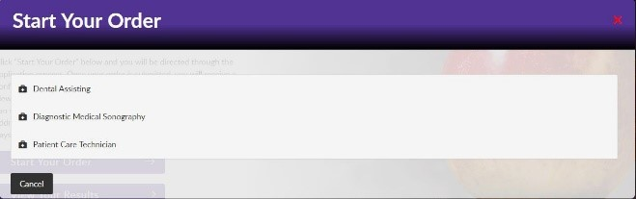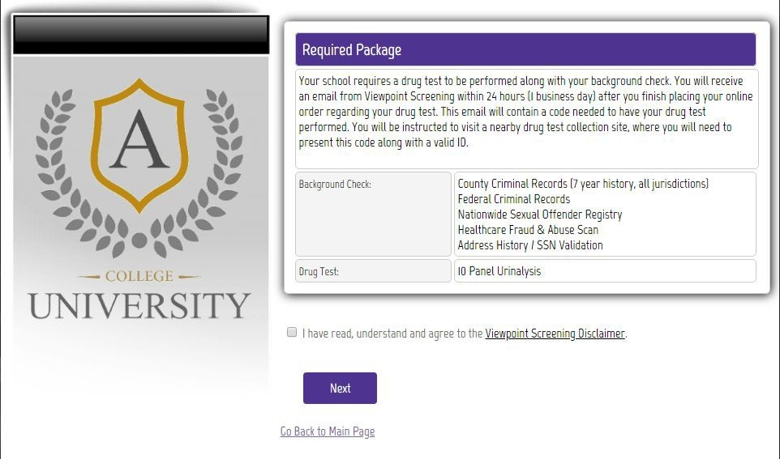

Once your order is submitted, you will receive a confirmation email containing a password. Use this info to log into your account to review other instructions you may have. You will also need this password to view your background check report.

**Drug Test** - You will receive an email with the subject line: “Viewpoint Screening Drug-screen registration” within 24-48 hours. This email will contain instructions and explain where you need to go to complete your drug test.

**Health Portal**

**You will have the capability to upload specific**  **documents required by your school**  **for**  **immunization,**  **medical**  **or**  **certification**  **records**.

* After you have placed your initial order, you will begin to get emails that notify you of additional items you need to take care of that are required by your school for clinical placement.
* To see the list of required immunizations and documents, after you have placed your order, go to[:](https://www.viewpointscreening.com/) [viewpointscreening.com](https://viewpointscreening.com/) [an](https://www.viewpointscreening.com/)d click on LOG IN in the right corner; use your email and password to log in.
* When logged in, click on **Health Portal** to view your specific requirements. Click on the **Question Mark** to expand the requirement and view the details of what is acceptable. Be sure to read these thoroughly, so you know what kind of documents you will n eed.
* As you complete your requirements, you can begin to upload them into your account at any time.
* To associate a document with a requirement: Click on the “Upload Document” button next to each requirement and select the correct file to upload. This can be done on a desktop computer, tablet or smartphone. All uploaded documents are typically reviewed within 24

hours. If your document is not compliant, you will receive an email

notifying you why it was not compliant, and how to fix it. This information can also be found in the “Student Messages” section of your account.

You will receive weekly email reminders to upload required documents, and you will be notified 30 days in advanced when a document is about to expire.

# SAMPLE

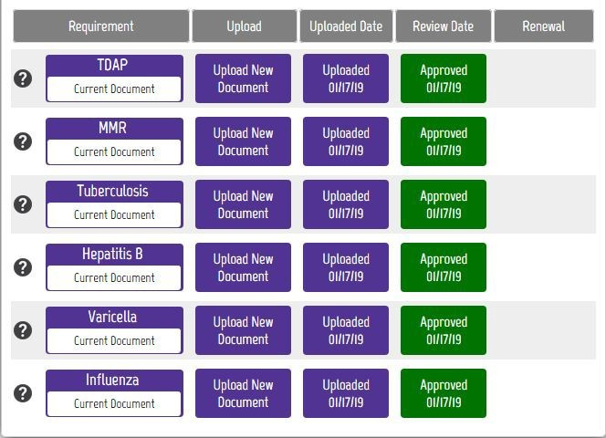

FOR BEST RESULTS:

DO: Be sure your name is visible on the document you upload. If your name is not on the document, it will be denied, and you’ll have to upload it again.

DO: Make sure you uploaded the correct document for a particular requirement.

DO: Be sure to read what is acceptable. For example, receipts are not acceptable as proof of influenza vaccination.

DO: Make sure document isn’t expired, and won’t expire during your clinical rotation.

**If you have any additional questions, please contact Viewpoint Screening via email at: studentsupport@viewpointscreening.com.**



**Or use the instant chat feature at** [**viewpointscreening.com.**](https://viewpointscreening.com/) **We are pleased to help you with this process!**

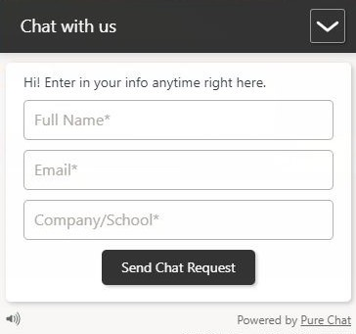

List of Requirements and Necessary Items

# Standard for Every Health Program

## Measles, Mumps and Rubella (MMR)

Submit documentation of one of the following:

2 Vaccines

Positive antibody titer (lab report required)

If your titer is negative or equivocal, new alerts will be created for you to repeat the vaccination series (2 vaccines administered after your titer).

If your series is in process, submit where you are in the series, and new alerts will be created for you to complete the process.

## Varicella

Submit documentation of one of the following:

2 Vaccines

Positive antibody titer (lab report required).

If your titer is negative or equivocal, new alerts will be created for you to repeat the vaccination series (2 vaccines administered after your titer).

If your series is in process, submit where you are in the series, and new alerts will be created for you to complete the process.

## Hepatitis B

Submit documentation of one of the following:

3 Vaccines

Positive antibody titer (lab report required).

If your titer is negative or equivocal, new alerts will be created for you to repeat the vaccination series (3 vaccines administered after your titer).

If your series is in process, submit where you are in the series, and new alerts will be created for you to complete the process.

## Tuberculosis

Submit documentation of one of the following:

1-Step TB skin test

If positive results, submit physician clearance documented on letterhead.

The renewal date will be set for 1 year. Upon renewal, one of the following is required:

1-Step TB skin test

If positive results, submit physician clearance documented on letterhead.

* Some facilities require a 2-Step TB test. Please follow instructions accordingly. *

**\*\*Note\*\*** If you have history of positive TB results you will need a licensed medical professional to complete the N.C. Department of Health and Human Health Services form #3405, “Record of Tuberculosis Screening” and upload.

## Tetanus, Diphtheria, and Pertussis (Tdap)

Submit documentation of a Tetanus, Diphtheria, & Pertussis (Tdap) vaccination, administered within the past 10 Years.

The renewal date will be set for 10 years from the date administered

If your documentation lists multiple Tetanus vaccinations on one line (e.g. Tetanus/DTP/DTaP/Td/Tdap), ensure that your physician indicates which shot was administered on each date listed.

*New DHHS recommendation being adhered to by the Health Department: any recent TD immunizations will receive the TD booster. *

## Influenza

Submit documentation of one of the following:

Influenza vaccination administered during the current flu season (September - March).

Declination signed by a healthcare provider.

The renewal date will be set for 1 year.

## Physical Examination

Download, print, complete, and re-submit the 1-page physical exam form.

Documentation must be signed by a medical professional and be dated within the past 6 months.

## Drug Screen and Background Check

Follow the steps by Viewpoint to go to appropriate testing facility.

Submit any necessary documents and complete any steps for background check.

## CPR Certification

Submit documentation of your current CPR certification.

Documentation must be directly from the American Heart Association (AHA) and must be the Basic Life Support (BLS). The AHA distributes electronic completion cards. This can be directly uploaded. If you received an actual card, make sure to sign the card and submit a copy of both side; front and back.

The renewal will be set based on the expiration of your current certification.

## HIPAA and Bloodborne Pathogen Training

Training will be administered through Viewpoint and certificates will be issued upon completion of the modules.

## Handbook Acknowledgment

After acceptance into your Health Program of interest, you will be given a handbook for that program. You will read the handbook, then sign the appropriate form. Prior to upload, ensure the Department Chair or Program Chair/Coordinator does not require their signature as well to meet this requirement. Once completed to the Program Chair/Coordinator’s standards, you will then upload the signed document.

## Code of Conduct

After review of the “Student Code of Conduct” as discussed in the “Student Rights, Responsibilities and Judicial Process” in the FTCC Student Handbook, you will click “Confirm” in acknowledgement that you understand and will agree to adhere to these expectations.

## Professional Liability Insurance

You will purchase medical liability on campus from the Cashier’s Office. There are two locations- in the Tony Rand Student Center and in the Thomas McLean Administration Building. You will upload your receipt for this purchase in this section to complete this requirement.