FTCC
CENTRAL STERILE PROCESSING PROGRAM

NEW STUDENT
WELCOME AND
ACCEPTANCE PACKET

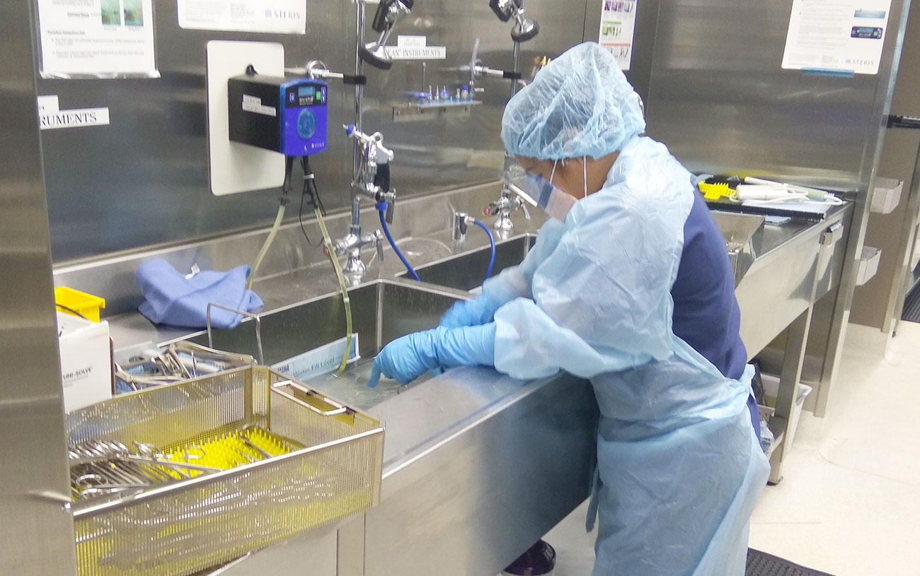
“Sterile Processing……. The Heart of the Hospital”

FTCC

Central Sterile Processing
Dear Sterile Processing Student:

Congratulations!
On behalf of all the faculty and staff here at Fayetteville Technical Community College, I would like to say welcome and thank you for choosing Central Sterile Processing as your future degree program of choice. You have made an exciting and rewarding decision to learn and grow in this profession. At the completion of this program, you will be eligible to graduate and receive a certificate of completion. Furthermore, you will be eligible to take the National Institute for Certification of Healthcare Sterile Processing and Distribution Personnel Examination (CBSPD).
It is critical that you review all of the information contained in your acceptance packet upon acceptance into this program. Your first day of class here at Fayetteville Technical Community College is extremely important. In class, we will discuss important departmental policies and procedures and you will also have an opportunity to ask any questions you may have. Attendance is extremely important. As you know, this program is accelerated and only 16 weeks in length. Therefore, it is extremely crucial that you attend class every day to kick off to an excellent start and finish!
You will get a detailed checklist with further information on each of the following, but the Program requirements that must be completed prior to classes beginning in August include:
• Register for classes (Program Coordinator will complete this for STP courses)
• Purchase textbooks (through SPDCEU website-info given by instructor)
• Current CPR Certification (must be American Heart Association)
• Uniforms through Castle Uniforms
• Purchase of Viewpoint Screening and Rotation Manager to submit required documentation
(Background Check, Drug Screening, Immunizations, etc.)
As always, I am available if any questions arise. Please email me at shocklet@faytechcc.edu or via phone (910) 678-9786.

Tammy Shockley CST, CSPDT, CIS, AAS, CSFA
Program Coordinator-Central Sterile Processing
FTCC SURGICAL SERVICES DEPARTMENT
CSP PROGRAM CHECKLIST

The following items must be completed prior to the first day of class, unless otherwise noted. These items are required for the program and delays can place the student behind in participation in classroom, laboratory, or clinical activities. Please initial beside each item upon completion and sign at the bottom once all items are ready for review. After accepting your seat, you may complete the checklist in any order to complete. Checklist must be completed by the end of Week 1 of classes and returned/signed to Program Coordinator.

- Student has officially accepted their seat into the CSP Program.

- Student has been registered for classes

- Purchase Rotation Manager- this can be done the first 2 weeks of class.

- Completed Background Check Application and Drug Screening- this can be done the first 2 weeks of class.

- Completed all required immunizations and upload into Viewpoint Screening (make sure to check requirements, as some have a time limit or require multiple doses or blood titers to show immunity). All immunizations must be up to date and will not expire prior to completion of the program.
  - Hepatis B Series – Blood titer for Hepatitis B may be required at some facilities in addition to the 3-shot series. Please check with your provider or health department on costs of this test.
  - Influenza – Current season only will be accepted-lot number and expiration date will be needed.
  - MMR – 2 Vaccinations or positive blood titer.
  - T-dap – Must be within 10 years.
  - Varicella (Chicken Pox) – 2 Vaccines or positive blood titer.
  - TB Skin Test – Performed annually; 2 PPD/TB Skin Tests are required for some clinical sites and all students must complete.

- Copy of BCLS (CPR) from American Heart Association only. Must state “Healthcare Provider and BLS” on the certificate, provide a copy to instructor. 2 years from issue and must not expire prior to completion of the program.

- Order uniforms from Castle Uniforms. Order form and online instructions are included in your Student Acceptance Package.

- Purchase books through Sterile Processing University (www.spdceus.com) ->Store+ ->Study Books ->Basics of SPD Textbook and Workbook 8th Edition ($155.00 + s/h), and workbook is ($40.00, plus s/h). Please order these two books only from website listed. FTCC Bookstore there is a 5-bundle pack $35.00

- Purchase of Medical Malpractice Insurance through the Cashier’s office in the _Tony Rand student center. And give receipt to Ms. Shockley

- Completed Physical Form. Document must be completed within the last 6 months. This form is the ONLY one accepted. No other physical form will be accepted.

- Code of Conduct – Read and sign, and give to Ms. Shockley

- HIPAA and OSHA Certificates through Rotation Manager.

There will be videos Ms. Shockley will submit to watch on HIPPA and Bloodborne Pathogens, sign that you watched and understand

- Student Handbook Acknowledgment (given first day of class, sign and give to Ms. Shockley

- Purchase Rotation Manager and complete CFV Clinical Requirements ($54.99/year)
- Acknowledgment of Program Policies (7 total) (given first day of class)
  - Turned into Instructor upon review
  - Policies are as follows:
    - Job-related Requirements
    - Background and Drug Screen
    - Cell Phone
    - Cheating
    - Confidentiality and Consent to Video/Photograph
    - Pregnancy
    - Equipment Agreement (if applicable)

______ 16. Logged into Canvas on the first day of class and located the syllabi.
- Program Orientation/Rules and Expectations first day of class.
- First day of class go into canvas and do your course entry quiz by 1159pm.

I, ____________________________ (printed name), have completed all of the above requirements in a timely manner and verify that all information provided is correct to the best of my knowledge. I understand that by signing, I am aware that any missing items will need to be addressed and corrected immediately to continue in the CSP Program.
Student Signature: ______________________________________________________
Date: ____________________________

Program Coordinator: Tammy Shockley AAS, CST, CSPDT, CIS, CSFA
Signature: ___________________________

Code of Conduct Statement

I acknowledge as a Health Program Student that I will adhere to the college’s “Student Code of Conduct” as outlined in the “Student Rights, Responsibilities and Judicial Process” in the FTCC Student Handbook.

Student Signature________________________________Date____________________

Student Name: __________________ DATATEL ID: ______________

Pre-Entrance Health Declaration

EVALUATION and ASSESSMENT: Evaluation and assessment require physical exam by a
healthcare provider.

Based on my evaluation & assessment of this student’s physical and emotional health on___________, he/she appears able to participate in the activities of a health profession in a clinical setting.

YES_____ NO_____

___________________________________________________ ________________________
Signature of Physician/Physician Assistant/Nurse Practitioner Date

__________________________________________________ _________________________
Print Name of Physician/Physician Assistant/Nurse Practitioner Area Code/Phone Number

___________________________________________________________________________
Office Address City State Zip Code

Directions for Ordering Textbooks
- Go to www.spdceus.com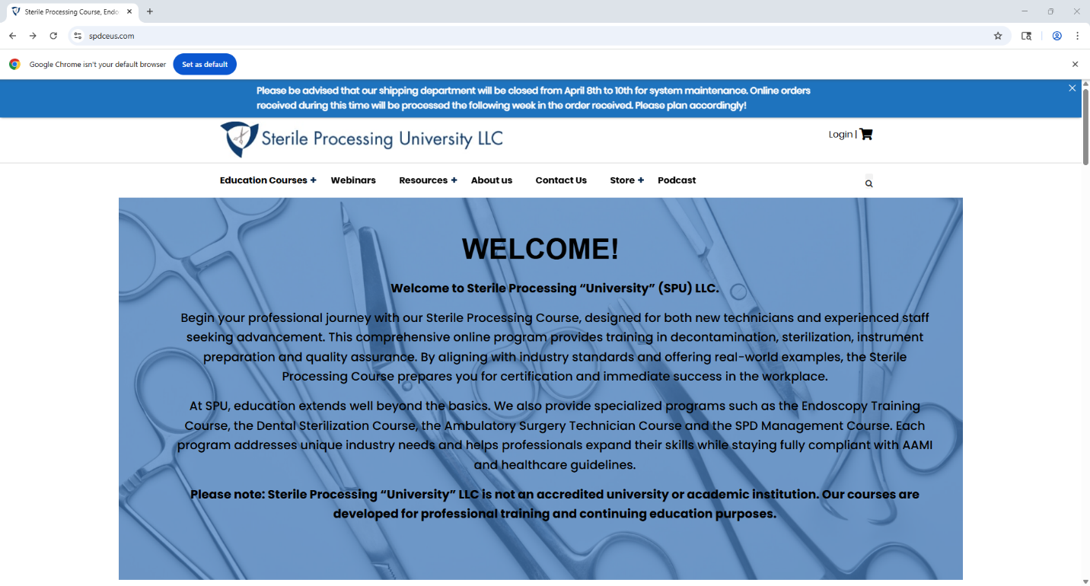

- Click on the “Store+” Button and select “Study Books”

- Select “Basics of SPD Textbook and Workbook 8th Edition Bundle”. Add to cart.

- Go to cart to view. Scroll to select the “shipping” portion to estimate costs. You will be asked to input your address (City, State, Zip) to give options. Priority Mail is the cheapest option, however, if you delay in purchasing your books, you may have to rely on more expensive alternatives.
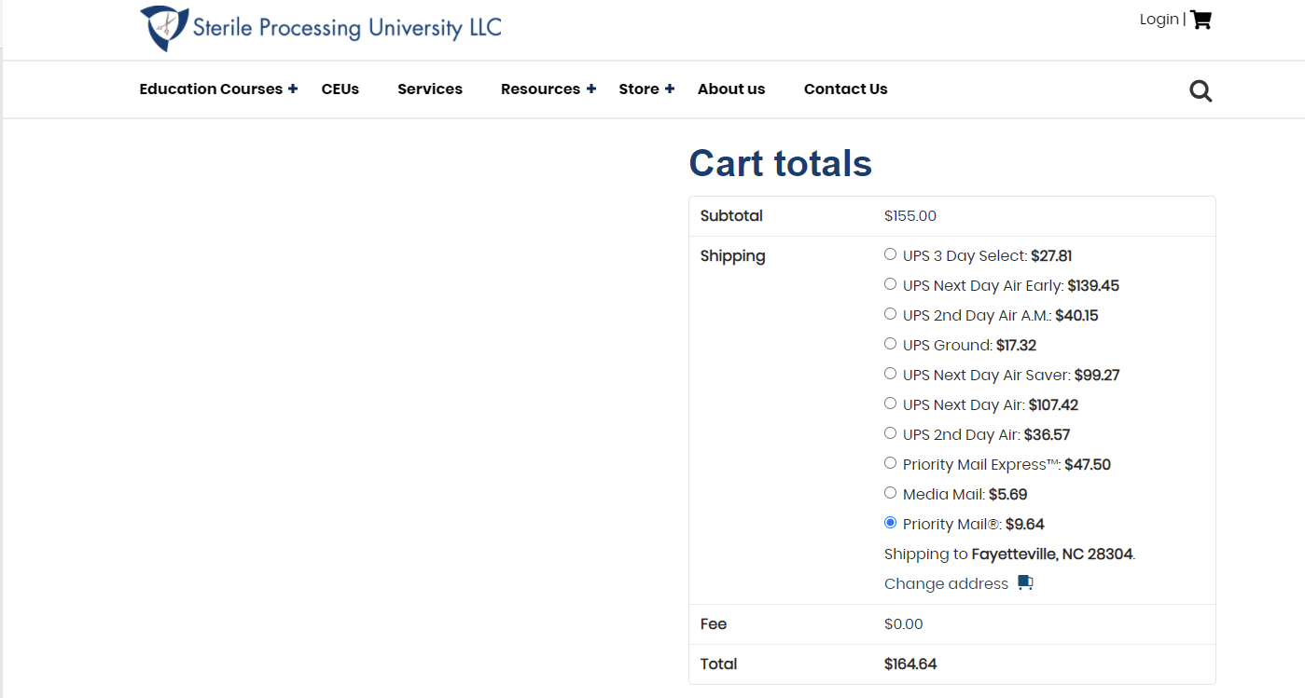
- Select “Proceed to Checkout” in the red rectangle after selecting your shipping option. Make sure to update after changing any selections prior to going to checkout. Fill out the billing information and select “place order”.

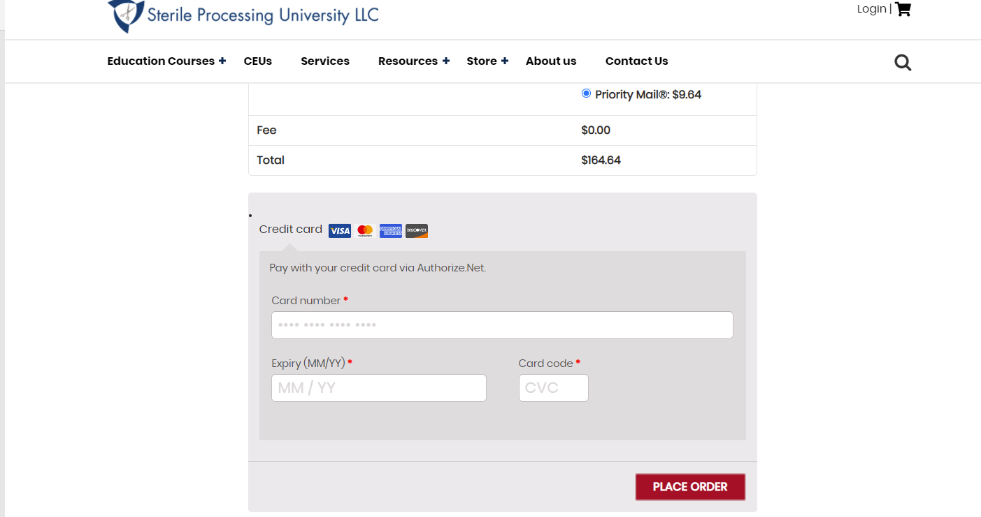
Welcome to Castle Uniforms and Welcome to the Healthcare Profession.

Congratulations on your acceptance to Fayetteville Technical Community College Central Sterile Processing Program. It is a privilege to represent the healthcare profession. Healthcare students are ambassadors for their school. As a student, you will work with the public, patients, and many types of medical and healthcare personnel. It is imperative that you are easily identified.
Your uniform identifies you as part of this privileged, entrusted group. Castle Uniforms, a North Carolina based, family run business since 1969, will offer you a student discount as you transition into this profession associated with integrity, honesty and empathy. The estimated cost of your required uniform package is $130.00 that includes, 1 royal blue top with the FTCC CSP logo, 1 pair of royal pants, 1 set of customized name tags and 1 black warm up jacket with the FTCC CSP logo. Additional items may be purchased.

We look forward to helping you with your uniforms, shoes and diagnostic tools:

Due to an increase in safety measures within manufacturers and shipping delays, customized student orders may take 6-8 weeks to complete. Please visit us by June 30th, 2026

- In-store fittings- group sales consultants are available to assist you Monday – Saturday from 10 AM to 6 PM at Castle Uniforms, 1800 Skibo Road #228, Cross Creek Plaza, Fayetteville, North Carolina 28303.
- Online Ordering- to order online, go to www.shopcastleuniforms.com and click on Group Sign in located at the top of the page.
- Personal Shopping Account- before ordering, please visit www.shopcastleuniforms.com and click on Create Personal Profile, located at the top to establish your student account and assure accuracy of shipping address. If you have shopped with us before, phone or email us for your account number to link to your existing account.

Payment Information
- Pre- payment is required on your custom student package at the time of placing an order.
- We accept MC/VISA/ Debit Cards, personal check, money orders and cash at time of order.
- Castle Uniforms will work with approved 3rd party billing agencies.
- Students using financial aid via the FTCC Bookstore need to come in and begin the ordering process this summer. Bookstore orders will not be available for pickup until they have been approved by FTCC.

Optional diagnostic tools, shoes, stethoscopes and socks available at student discount
- Shoes-appropriate shoes may include closed toe, closed heel, supportive for standing on your feet all day and made of materials that will not allow body fluids to absorb.
- Socks-graduated compression that forces blood and fluid flow back up your legs
- Stethoscopes-one of the most important tools in a healthcare providers arsenal
- Wrist Watch- necessary to document vital signs
- Bandage Scissors, BP cuffs, Hemostats, Pulse Oximeter and more.

We look forward to dressing you in your journey to help others in your medical profession.

Sincerely,

Castle Uniforms—Note prices are approximate

1800 Skibo Road # 228 Cross Creek Plaza Fayetteville, NC 28303 p. 910-485-4429 f. 910-485-4429
SO #_____________ |  |  |  | Castle Uniforms |  |  | #_______
 |  |  |  | www.castleuniforms.com
1800 Skibo Rd, Suite 228, Fayetteville, NC 28303 (phone) 910-485-4429 (fax) 910-485-1825
FTCC Central Sterile Processing 2026
First_________________________________MI____Last______________________________________
Address____________________________________________________________________
City_____________________________________________________ST______ZIP_________________
Mobile # for Text Reminders_______________________ Email Receipt of Order_____________________________
Requirements
1 Royal Blue Top with FTCC Central Sterile Processing Logo, 1 Pair of Royal Blue Pants
1 Black Warmup Jacket with FTCC Central Sterile Processing Logo,
1 Set of Nametags, and Black Slip Resistant Shoes. Black Compression Socks are Recommended.
Customized Student Orders Take Approx. 6-8 Weeks to be Completed.
Please Create Your Student Account at www.shopcastleuniforms.com!
Website: www.shopcastleuniforms.com Group Traditional Student
PAYMENT POLICY: - 1/2 deposit is required to order student uniforms. Order must be paid in full to pick up items.
Packed | Qty | Size | Item | Description | Size | Unit Price | Total
 |  |  | NAMETAG | NAM-FTCCCSP
 |  |  |  | Please Print First Initial, Last Name to Appear on Nametag |  | $15.00
 |  |  | LADIES | Ladies Royal Blue Mock Wrap or V-Neck Top | XXS-XL
 |  |  | TOP | IRG-2803 RYL Mock Wrap OR IRG-2801 RYL V-Neck | 2X-3X | $32.99-$39.99
 |  |  |  | PRO-FTCCSP-WHITE | 4X-5X (V-neck only)
 |  |  | LADIES | Ladies Royal Blue Pants | XXS-XL
 |  |  | PANT | IRG-6801 RYL Elastic Waist OR IRG-6803 RYL Jogger | 2X-5X | $28.59-$30.99
 |  |  |  | Available in Petites XS-2XL & Tall XS 2XL
 |  |  | MEN'S | Men's Royal Blue V-Neck Top | XXS-XL
 |  |  | TOP | IRG-2851 RYL | 2X-3X | $35.39-$37.79
 |  |  |  | PRO-FTCCSP-WHITE
 |  |  | MEN'S | Men's Royal Blue Pant | XS-XL | $30.59-$32.99
 |  |  | PANT | IRG-6851 RYL | 2X-3X
 |  |  | LADIES | Ladies Black Warmup Jacket W/ logo | XS-XL
 |  |  | WARMUP | IRG-2811 BLK PRO-FTCCSP-WHITE | 2X-3X | $37.99-$39.39
 |  |  | MENS | Men's Black Warm-up Jacket w/ logo | SM-XL
 |  |  | WARMUP | Che WW320 BLK PRO-FTCCCSP-WHITE | 2X-5X | $41.79-$43.19
 |  |  | SOCKS | CHE-TRUESUPPORT ONYX Black 8-12mmHg Compression Knee-Hi Sock | OPTIONAL
 |  |  | SHOES | Closed heel/toe Black Only- Slip Resistant |  | Student Pricing
Important Information: Please initial and sign. |  |  |  |  |  | Subtotal
____Customized items must be paid in full. |  |  |  |  |  | Tax 7%
____1/2 Down deposit must be secured on remaining items. |  |  |  |  |  | Total
____Order must be paid in full to receive any part of the order. |  |  |  |  |  | Deposit
____Any cancellations made after 5 business days will result in a $15 restocking fee. |  |  |  |  |  | Due
____No refunds or exchanges on customized items.
SIGNATURE REQUIRED/ORDER APPROVAL: |  |  |  | Date

Rotation Manger for Clinical Sites
https://rotationmanager.com/app/signup/index/home
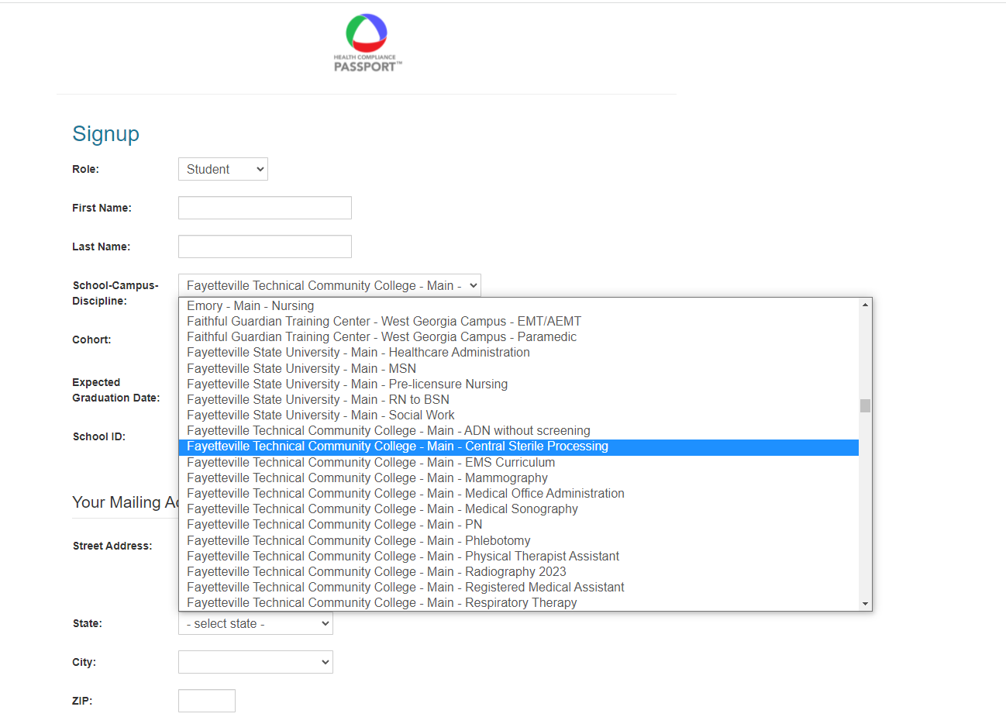
- Fill out all appropriate information blocks, using your FTCC student email and single log-in password for ease of use.

- Submit payment information.
  - Price: Your will be charged $54.99 today and $54.99 every 12 month(s).
  - NOTE: Students MUST close their accounts at completion of program to avoid reoccurring payment charge.
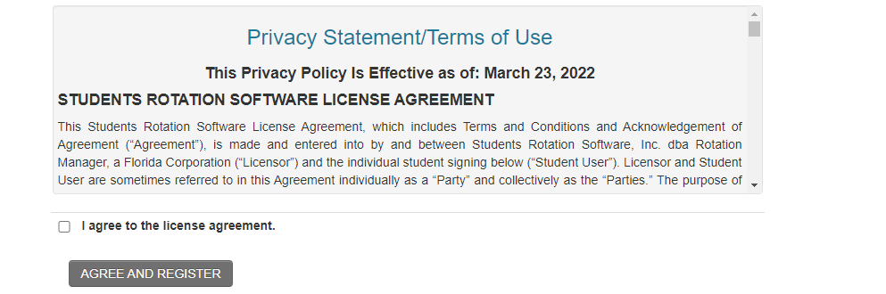

- Once registered, please complete all clinical requirements and checklist.

Central Sterile Processing Department

I understand that any breach in patient confidentiality may result in my dismissal from the Central Sterile Processing Program here at FTCC, and/or legal action to include the disbursement of legal fines.

Printed Name and Student I.D.:

Signature and Date:

