

MANDATORY ORIENTATION SESSION
When: November 18, 2021 12:00 PM – 4:00 PM
November 19, 2021 8:00 AM – 12:30 PM
(YOUR DATE WILL BE ASSIGNED BY LAST NAME)
Where: Continuing Education Center, CEC 118
All incoming students are required to attend!
You will lose your seat in the program if you do not attend Orientation.
BRING YOUR LAPTOPS!!!!

YOU ARE REQUIRED TO SELF-REGISTER FOR
2022SP NUR 111
VIA SELF-SERVICE
UNIFORMS 
- Required uniform package selected at Castle Uniforms of Fayetteville.
- Students will receive a reduced group rate.
- Be prepared to pay a 50 % deposit on the day of package order.
- Uniforms must be ordered in-store or online before
DEC 1 at CastleUniforms (opens in new window).
- Direct Link to CastleUniforms
CPR
CANNOT BE completed online! Must be face to face!
- Required to maintain a current certification from the American Heart Association BLS Health Care Provider CPR throughout the program.
- You may contact FTCC Continuing Education for upcoming course information at 910-678-8251.
- Must be completed by JAN 3, 2022.
- 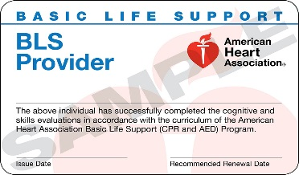

CRIMINAL BACKGROUND / DRUG SCREEN / IMMUNIZATION TRACKER
REQUIRED to attend clinical in the program.
- Viewpoint Information will be provided in a follow-up email and must be reviewed prior to and accessible at Orientation.
- No student will be denied admission to the program for a problem with the background/drug screen. However, a student may be subject to dismissal from the program if denied access to a clinical agency based on the background/drug screen results.
- You may begin gathering/collecting your documents (immunization records, shot records, CPR Certification, etc.) so that you have it readily available when it is required to submit.
- Student Handbook will be available with your NUR 111 Course.

If you are currently enrolled in classes, remember your acceptance is still contingent upon maintaining the required 2.5 Health GPA and 2.0 Cumulative GPA for admission to the program!
To the Incoming ADN Spring 2022 Class:
Again, congratulations on your acceptance to the Associate Degree Nursing program!!
If you have any questions or concerns, please email me at: sporberh@faytechcc.edu, or contact the nursing office via
Ms. Melanie Parker for assistance at: (910) 678-0183 or email: parkerme@faytechcc.edu.
Sincerely,
Dr. Hadley Sporbert
Department Chair, Associate Degree Nursing

Mandatory Orientation Information
MASKS REQUIRED IN ALL BUILDINGS AND CLASSROOMS

November 18, 2021
Last Names Attending: A – M
11:45 AM Sign-In
12:00 PM Doors Close

November 19, 2021
Last Names Attending: N – Z
7:45 AM Sign-in
8:00 AM Doors Close
- Visitors are not permitted to attend the orientation (NO spouses, children, friends, extended family)
- Dress in appropriate Business Casual attire. MASKS Are REQUIRED at all times.
- Bring a writing tool (pen, pencil).
- Bring your Laptop!

Below are options for your convenience in completing the CPR Requirement. CPR MUST BE COMPLETED FACE TO FACE!
FTCC CONTINUING EDUCATION IS OFFERING CPR CERTIFICATION:
Please call 910-678-8386 for registration information, or visit the Neill Curry Building, Room 2.
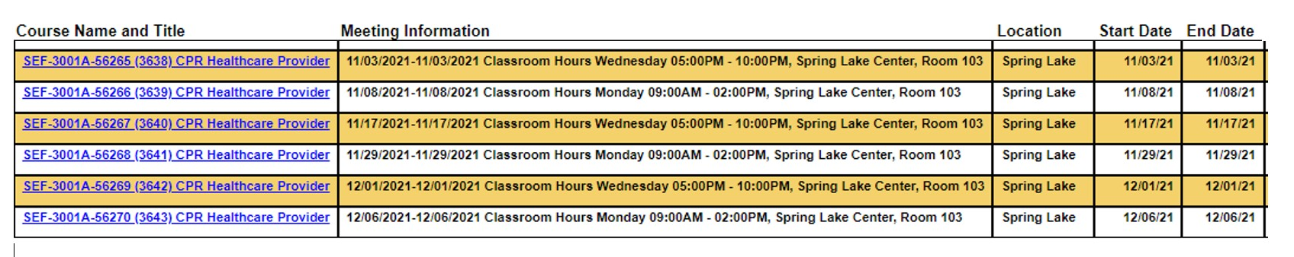

OR,

You may visit: https://cpr.heart.org/en/ To locate a Local AHA BLS CPR Provider Class



