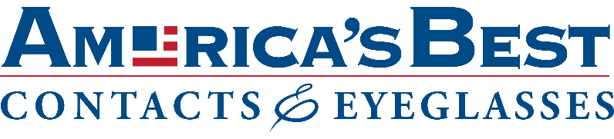

**Fayetteville**

**Front Desk Receptionist**

* Part-time

**Job Description**

**What would you do? – The Specifics**

As the face of our stores, Receptionists are responsible for greeting and welcoming customers in a friendly manner as soon as they arrive at the store. They keep organized patient records and help patient schedules flow smoothly. They’re the glue to our operations, helping everyone to stay on track. The role provides prompt, courteous service to customers either on the phone or in person.

* Ensures high quality customer service while following all safety protocols.
* Ensures a smooth flow of customers through the store.
* Answers, screens, and forwards incoming phone calls in accordance with National Vision protocol.
* Processes and understands managed care plans while obtaining document information from the insurance company as needed.
* Provides customers basic and accurate information.
* Schedules and confirms appointments, follow-up visits and classes.
* Files all patient records daily and pulls patient files for the next day's appointments.
* Checks order status and notifies customers when orders are in or of any delays.
* Keeps reception area tidy and presentable with all necessary materials.
* Receives, sorts, distributes daily mail/deliveries and maintains inventory of office supplies.
* Participates in regularly scheduled mandatory communication meetings.

**Qualifications:**

**Are you the right fit? – The Suitable Talent**

* Experience as a Receptionist, Front Office Representative or similar role preferred but not required.
* 0-2 years related experience or training preferred.
* Experience handling multiple phone lines preferred.
* Strong customer service skills required
* Strong organizational skills required

**Education:**

* High School Diploma or equivalent.

**Taking care of our people**

We understand the importance of financial health and security, and because of that, we provide competitive compensation to all Associates – including bonus potential for every position in the store! We also offer a comprehensive benefits package including health and dental insurance, 401k retirement savings with company match, flex spending account, paid personal time off, paid company holidays, parental leave, employee eyewear discount and much, much more. At National Vision, we strive to deliver opportunities for professional growth and long-term career fulfillment. We provide training programs, access to educational courses and pride ourselves on the ever-increasing amount of promotions from within.

**To Apply:**

<https://jobs.smartrecruiters.com/oneclick-ui/company/NationalVision1/publication/2a7d0cb8-9493-4fe0-bc1e-57fc27570349?dcr_ci=NationalVision1>