In your gradebook click the chevron next to Orientation Activity, Select View Grade History

 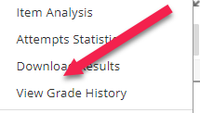

Next Click Download

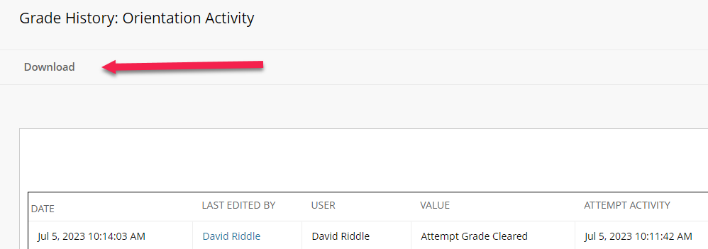

Leave the default option as they are and click Submit

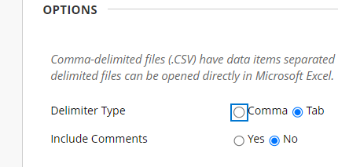

Click Download, this will give you an excel spreadsheet of all activity in this column, including students that may have dropped and are no longer visible in the gradebook.

The file should be named in this format-

YearSemester_Prefix_Course###_section####_Census

Examples:

2023SU_ENG_112_1B01_Census

*Co-req. courses should be labeled together:

2023SU_ENG_011_111_19D1_Census