**Fayetteville Technical Community College**

**Allied Health Programs Admissions GUIDE**



**Information for Prospective Allied Health Students**

**Fayetteville Technical Community College**

**Allied Health Programs Admissions GUIDE**

On behalf of the Fayetteville Technical Community College Allied Health Programs Admissions office, thank you for your interest in our Allied Health Programs. This guide provides general information on the competitive admissions process and criteria used.

You can find more specific program information in each of the Allied Health program’s handbooks.

Again, thank you for your interest.

**COMPETITIVE ADMISSIONS PROCESS**

1. All Allied Health Programs, except Mammography, Ophthalmic Surgical Asst and Surgical First Assistant have a competitive admissions process.
2. There are limited seats for each Allied Health program.

|  |  |  |  |
| --- | --- | --- | --- |
| **Program** | **Seats** | **Program** | **Seats** |
| Dental Assisting | 36 | Physical Therapist Assistant | 19 |
| Dental Hygiene | 34 | Polysomnography | 20 |
| Emergency Medical Science | 24 | Radiography | 25 |
| Medical Laboratory Technology | 20 | Respiratory Therapy | 47 |
| Medical Sonography | 14 | Speech Language Pathology Assistant | 25 |
| Pharmacy Technology | 20 | Surgical Technology | 15 |

1. Before selection into a program, applicants must meet pre-requisites and gain competitive points. **\*\*Official High School** **transcript/or GED on file** in FTCC Admissions is part of the pre-requisite requirements.
2. Students may take the related courses at FTCC as they prepare to compete and will be enrolled in a pre-health program of study during this time, but can also be enrolled in another major and still apply.
3. Phases: There are three phases to the health application process.
4. **Phase I**: General FTCC Admissions for all students (Includes FTCC General Application, Financial Aid, Turn in High School and College transcripts, College placement assessment, Request a Student Education Plan (SEP) from the Allied Health Advising Center) to learn next steps. Email: [FTCCAHAC@faytechcc.edu](mailto:FTCCAHAC@faytechcc.edu) or [healthproadmissions@faytechcc.edu](mailto:healthproadmissions@faytechcc.edu)
5. **Phase II**: Health Application Process (Includes Submitting Health Program Application online (<https://www.faytechcc.edu/academics/healthcare-programs/allied-health-programs-admissions/> ), Receiving Notifications about status, Appeal Process)
6. **Phase III**: If a program receives fewer applicants than the maximum capacity for their program, the admissions process for that program may be re-opened (usually in February).
7. All students interested in an Allied Health program will be coded to a “holding” program - Associate in General Education-Health A10300H (xxx) as the program major. **\*\***Please note that students cannot graduate from the A10300H (xxx) program. If students wish to apply to graduate from a second program before they are selected for a seat in their “Health” program, they will need to add a Program 2nd Option or dual major (e.g. Associate in Art-A10100, Associate in General Education-A10300 or Associate in Science-A10400 are just a few options).

**ALLIED HEALTH ADMISSION REQUIREMENTS**

1. **Associate Degree Programs**:
   1. Must meet FTCC Admission Criteria (refer to page **16** of the College Catalog).
   2. Must meet specific Allied Health Admissions Requirements and program pre-requisite requirements (refer to page 16 & 36 of the College Catalog). Each program’s pre-requisites are shown in the College Catalog and the individual Program Fact Sheets which are all located at [Health Programs Web Page](https://www.faytechcc.edu/academics/healthcare-programs/) (<https://www.faytechcc.edu/academics/healthcare-programs/>)
   3. Official High School Transcript or GED is required on file in Admissions to apply to a Health Program. **\*\***(Exception: High School Seniors may initially turn in a partial transcript when they apply to FTCC and then request a manual health program application via email to: [healthproadmissions@faytechcc.edu](mailto:healthproadmissions@faytechcc.edu)).
   4. Must meet the **minimum 2.0** Cumulative GPA. (This is the GPA of all course work completed at FTCC)
   5. Must meet the **minimum 2.5** HEALTH GPA as calculated on the Health Applicant Rating Form (the Health GPA is calculated from the designated related courses for the program you apply to). Each program has designated general education courses that earn competitive points.
   6. Maximum of two attempts on all prerequisite and science courses. Pre-requisite courses do not expire. Related Science courses may expire and another 2nd attempt may be approved by Department Chairs. (Exceptions granted by Department Chairs)
   7. Related Science courses must be current within 5 years of entering the program.
2. **Diploma/Certificate Programs**:
3. Must meet FTCC Admission Criteria (refer to page 16 of the College Catalog).
4. Must meet specific Allied Health Admissions Requirements and program pre-requisite requirements (refer to page 16 & 36 of the College Catalog). Each program’s pre-requisites are shown in the College Catalog and the individual Program Fact Sheets all which are all located at [Health Programs Web Page](https://www.faytechcc.edu/academics/healthcare-programs/) (<https://www.faytechcc.edu/academics/healthcare-programs/>)
5. Official High School transcript or GED is required on file in FTCC Admissions to apply to a Health Program. **\*\***(Exception: High School Seniors may initially turn in a partial transcript when they apply to FTCC and then request a manual health program application via email to: [healthproadmissions@faytechcc.edu](mailto:healthproadmissions@faytechcc.edu)).
6. Must meet the minimum 2.0 Cumulative GPA (This is the GPA of all course work completed at FTCC).
7. Must meet the minimum 2.0 HEALTH GPA as calculated on the Health Applicant Rating Form (the Health GPA is calculated from the designated related courses for the program you apply to). Each program has designated general education courses that earn competitive points.
8. Maximum of two attempts on all prerequisite and related Science courses. Pre-requisite courses do not expire. Related Science courses may expire and another 2nd attempt may be approved by Department Chairs. (Exceptions granted by Department Chairs)
9. Related Science courses must be current within 5 years of entering the program.

**WHEN & HOW CAN STUDENTS APPLY TO THE HEALTH PROGRAMS?**

**WHEN CAN STUDENTS APPLY?**

* + - 1. Students can apply to the competitive Allied Health Programs between **November 1st and midnight January 30th** to compete for the following FALL (AUGUST) entry.
      2. All programs have the option to **“Re-Open”** their application window after the initial closing of the window if they determine they would like additional applicants. The “re-opened” programs will be posted on the webpage.
      3. The HEALTH PROGRAM APPLICATION is located at this webpage link: <https://web03apps.faytechcc.edu/healthapp>
* If not already logged in use FTCC Student Username and Password
* Click on **APPLY FOR PROGRAM** and Select the Health Program you wish to apply to and submit. A receipt will show on the screen for students to either print or screen shot for their records.
* ***If any errors are encountered, you may be missing a pre-requisite. If you believe you are not missing any items, you may email: [healthproadmissions@faytechcc.edu](mailto:healthproadmissions@faytechcc.edu) to request a review and possible manual health application. Note: The system takes several hours to update after new transfer credits have been added to academic records or TEAS Scores posted. **IF you recently turned in documents, try again later**.
  + - 1. HIGH SCHOOL SENIORS Interested in Applying to Health Program: High School Seniors will not be able to complete the online Health Program Application. High School Seniors who have **met the minimum** requirements for the health program of choice may request a manual application. If not already enrolled in High School Connections (HSC) at FTCC, first apply to FTCC and turn in a partial High School transcript to FTCC Admissions. Then email: [healthproadmissions@faytechcc.edu](mailto:healthproadmissions@faytechcc.edu) to request further instructions on how to apply to the health program of your choice. Include Full Name, FTCC Student ID Number and program to which you wish to apply for.

**HOW DO STUDENTS APPLY?**

1. **Where Do I Find the Student Health Program Application**? The Student Health Program Application is located at this webpage <https://web03apps.faytechcc.edu/healthapp>

**Then Login with FTCC Student Username and password if prompted. (You may already be logged in to your Self-Service Portal).**

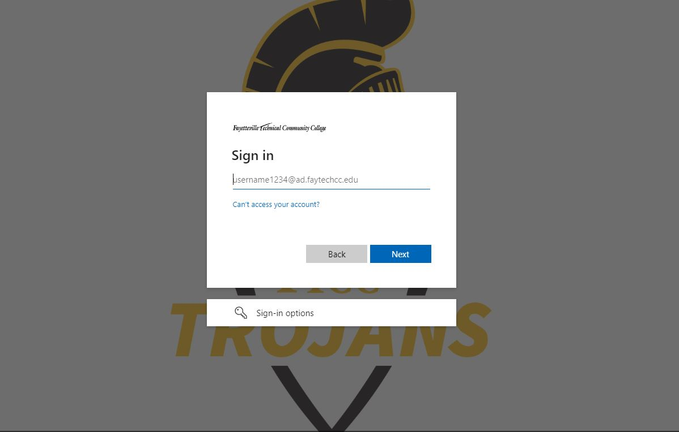

1. CLICK ON **APPLY FOR PROGRAM** at BOTTOM LEFT.

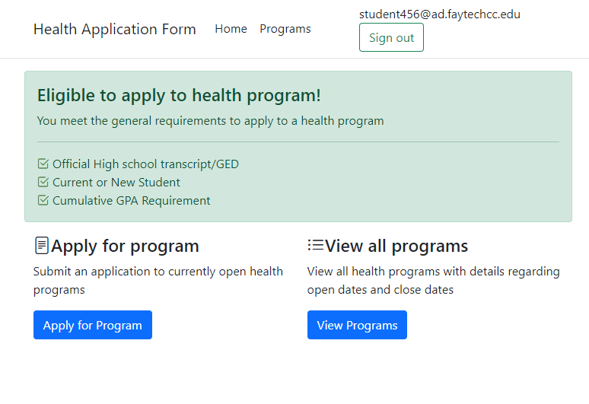

1. CONFIRMATION OF RECEIPT OF APPLICATION will appear on screen– PRINT or SCREEN SHOT/take picture for your records

A short message will appear confirming receipt of application

1. **\*\*IF YOU ARE NOT ELIGIBLE TO APPLY, A SCREEN SIMILAR TO THE ONE(s) BELOW WILL APPEAR. YOU MUST COMPLETE ANY ITEMS MISSING AND TRY AGAIN.**

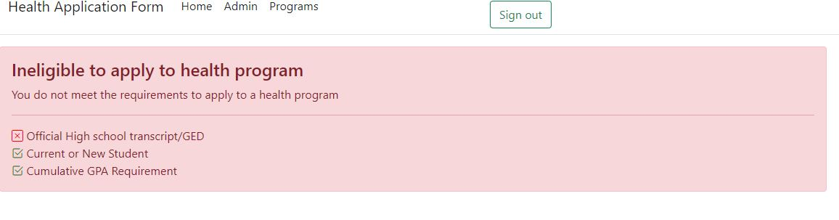

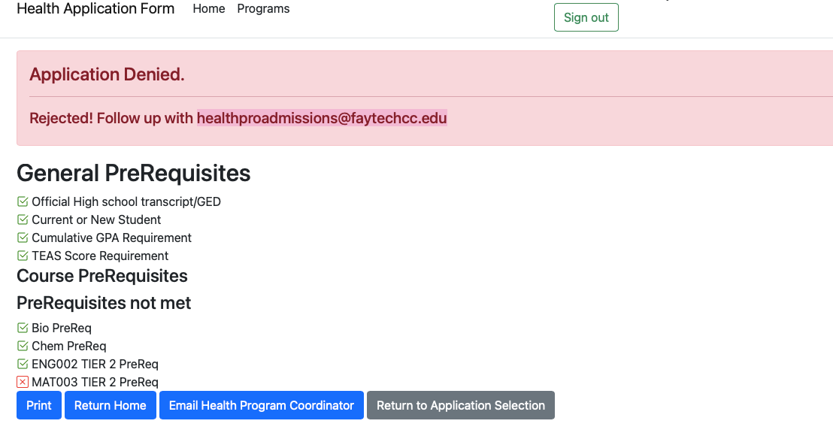

1. **IF YOU BELIEVE YOU HAVE COMPLETED ALL ITEMS, PLEASE ALLOW 24-72 HOURS FOR FTCC ADMISSIONS TO UPDATED YOUR RECORDS. THEN YOU MAY EMAIL: [healthproadmissions@faytechcc.edu](mailto:healthproadmissions@faytechcc.edu) TO REQUEST REVIEW OF RECORDS AND POSSIBLE MANUAL HEALTH PROGRAM APPLICATION. INCLUDE STUDENT ID #, FULL NAME AND PROGRAM YOU WISH TO APPLY TO.

1. After you have already applied to a program, you will not be able to apply to another health program. You will be able to view your current application.

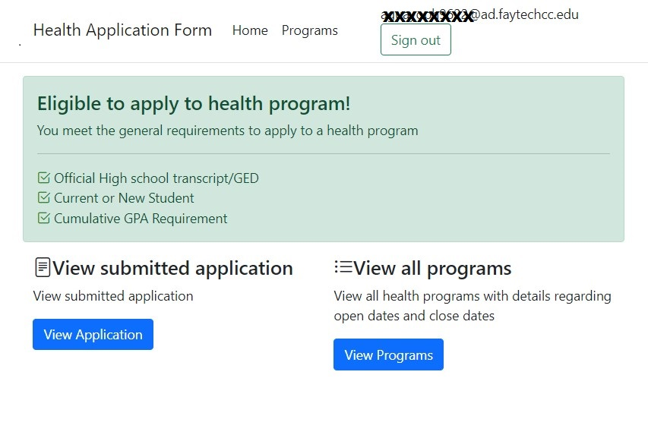

**CATEGORY I vs. CATEGORY II APPLICANT**

1. Category I
   1. Meets all pre-requisite requirements
   2. Meets midnight of January 30 deadline
   3. Ranked before all Category II applicants
2. Category II
   1. Currently enrolled in final pre-requisite course (excludes the TEAS test).
   2. Misses January 30 deadline and is allowed to apply because the program “re-opens” the application window.
   3. Ranked after all Category I applicants

**PRE-REQUISITE NOTES**

1. Must be completed prior to January 30 (all programs) to be considered a Category I applicant.
2. Applicants can apply if they are registered at the time of application to take their FINAL pre-requisite course, but will be considered a Category II applicant. (Will need to request a manual application and provide proof of enrollment in final pre-requisite if not taking at FTCC).
3. May be obtained through testing, college course transfers, courses taken at FTCC, and/or certificates. **Must show current proficiency in College Placement MAT025 (or placement test equivalent) (program specific) through the “current” FTCC placement criteria. Must show current proficiency in College Placement ENG025 (or placement test equivalent) (program specific) through the “current” FTCC placement criteria.
4. Biology and Chemistry: Can be taken at FTCC if they were not successfully completed in high school (Biology/Chemistry) or other college.
5. Pre-requisite Biology courses accepted include High School BIOLOGY (1 complete credit/unit with a “C” or higher-*transcript must include grading scale); BIO092 or BIO094 taken at a NC Community College; BIO 110, BIO 111 or other equivalent college Principles of Biology or General Biology with a Lab.
6. Pre-requisite Chemistry courses accepted include High School CHEMISTRY (1 complete credit/unit with a “C” or higher - *transcript must include grading scale); CHM081, CHM092, CHM094 taken at a NC Community College; CHM131/131A, CHM130/130A, CHM135, CHM 151 or other equivalent college Chemistry with a Lab.
7. Pre-requisite courses may only be attempted twice.
8. Pre-requisite courses do not expire, but entrance assessment test scores expire.
9. Different for each health program – Each program has different pre-requisites and these are shown in the College Catalog and the individual Program Fact Sheets which are all located at [Health Programs Web Page](https://www.faytechcc.edu/academics/healthcare-programs/) (https://www.faytechcc.edu/academics/healthcare-programs/)
10. **Official transcripts must be received in FTCC Admissions by the last day of the application window in order for the courses to be considered for pre-requisite consideration.** Transcripts received after the closing of the application window will not be considered.
11. Transfer credits from other colleges are awarded as determined by the **FTCC Admissions Transcript Evaluation office**. For questions about transfer credits visit this webpage: <https://www.faytechcc.edu/apply-now/ftcc-admissions/#staff>

**TEST OF ESSENTIAL ACADEMIC SKILLS (TEAS)**

**\*\*\***These Allied Health Programs require the ATI TEAS prior to completing the Health Program Application: **Dental Hygiene and Medical Sonography**

1. You must register to take the TEAS Test at [ATITESTING](http://www.atitesting.com) (www.atitesting.com)
2. There is a fee associated with the test and it is the student responsibility.
3. If the test is taken at another location other than a reserved seat at FTCC, applicants are responsible for having the score shared by [www.atitesting.com](http://www.atitesting.com) to the FTCC testing office. Paper copies / emails from students are not accepted.
4. The TEAS Score must be in the applicant’s academic record at FTCC by the last day of the application window to be considered. **Note: make sure you are requesting the correct test result transcript if you have taken the test more than once.
5. Test scores received in the FTCC Testing office after the last day of the application window will not be considered. (midnight of January 30 for all programs – unless the program has re-opened the application).
6. Scores must not be more than 3 years old at the time of health application.
7. Visit this FTCC Academic Assessment and Placement Testing webpage for additional information/guidance: <https://www.faytechcc.edu/campus-life/academic-resources/academic-assessment-placement-testing/>

**DESIGNATED RELATED COURSES (Point-Earning courses) NOTES**

1. The program designated general education point-earning courses completed will be awarded competitive points based on the grade earned.
2. These are the courses required for a program that are not program specific (i.e., ENG, MAT)
3. Science courses may only be attempted twice. (Expired courses will not be counted as an attempt.)
4. Related Science courses are valid for 5 years. (Courses must not be more than 5 years old at time of Entry into the program.) Courses that are no more than 5 years old when the application window opens will be awarded competitive points. (e.g., expires FA24 or SP25, applying FA24. Courses that expire prior (e.g., expired SP24 or SU24, Applying FA24) to the opening of the application window will not earn competitive points. If the course expires before the program starts and applicant was selected to a seat, applicant must retake the course as directed by the Department Chair. (**The Department Chair may only waive the requirement to retake the course before entry into the program, but may not waive the competitive point award criteria.)
5. **These programs require a grade of “B” or higher in the related Science courses**: Dental Hygiene, Medical Sonography, Pharmacy Tech, Physical Therapist Asst, Radiography, Speech Language Pathology Asst., and Surgical Tech.
6. **These programs require a grade of “C” or higher in the related Science courses**:

Dental Assisting, Emergency Medical Science, Medical Laboratory Tech, Polysomnography and Respiratory Therapy.

1. If applicants apply with a lower than the required grade in the related Science courses, “0” competitive points will be earned for that courses grade on the Health Applicant Rating Form.
2. Related courses are shown on the Student Education Plan (SEP) and the FTCC Web page.

**CUMULATIVE GPA VS. MAJOR GPA VS. HEALTH GPA**

1. Cumulative GPA
   1. Grade Point Average based on all coursework attempted and completed at FTCC.
   2. Includes courses not required for the health program.
2. Major GPA
   1. Grade Point Average based only on all courses required for current program.
   2. Does not include courses not required for the health program.
3. Health GPA (on Health Applicant Rating Form)
   1. Grade Point Average based on only the designated related courses used for computing competitive points on HARF (excluding the Elective or ACA course).
   2. Includes related course grades that have not expired or been forgiven.

**MINIMUM GPA NOTES**

1. All Health programs require a minimum Cumulative GPA of 2.0.
2. Degree Programs require a minimum Health GPA of 2.5.
3. Diploma / Certificate programs require a minimum Health GPA of 2.0.
4. Cumulative and Health GPA requirements must be maintained through the selection process, including Spring and Summer semesters following application to the program.
5. If an applicant has a less than 2.0 Cumulative GPA, the applicant should check with the Dean of Enrollment at FTCC, Student Center Room 123 and/or the Advisor to see if Grade Forgiveness is an option to increase the Cumulative GPA. Some course grades may be forgiven if more than 4 years old. (See the [Student Fill in Form WebPage](https://www.faytechcc.edu/current-students/student-forms/#G) (www.faytechcc.edu/current-students/student-forms/#G) and select form G-8.

**INITIAL COMPETITIVE POINT CALCULATION**

1. Competitive Points can only be earned by:
   1. Grades in the Designated Related Courses (excluding ACA/Humanities/Elective) for the programs.
   2. Information Session/Competitive Point Worksheets per each program.
2. The **Initial** Competitive Points will be recorded on the Health Applicant Rating Form (HARF). The “additional” competitive points that are awarded by the specific health program will be awarded after receipt of the Health Applicant Rating Form. The Rating Forms will be emailed to FTCC student emails starting sometime after the application window closes.
3. Higher grades can earn you substantial competitive points and increase chances for acceptance in a health program.
4. Low grades can lower the Health GPA and place applicants in the INELIGIBLE status.
5. **For MOST of the ALLIED HEALTH PROGRAMS**: Each letter grade earns a numeric value of points per credit hour. (A = 4 points per credit hour, B = 3 points per credit hour, C = 2 points per credit hour).
6. **For DENTAL HYGIENE PROGRAM**: See the most current Competitive Point Worksheet at the **FTCC Dental Hygiene webpage for details**. <https://www.faytechcc.edu/academics/healthcare-programs/dental-hygiene/>

There is a set # of points for the COM/ENG/PSY/SOC courses based on grade of A=4, B-3, C=2 and for **Sciences** courses **1st attempt** = 10 points for A, 5 points for B; 2nd attempt = 7 points for A and 3 points for B. *exceptions noted on worksheet.

1. **The following programs require “B” or higher** grades in related Science courses and if applying with a “C” in these courses, will earn “0” points in the Health Applicant Rating Form Calculator:

Dental Hygiene / Medical Sonography / Pharmacy Technology / Radiography / Speech Language Pathology Asst / Surgical Technology

1. **The following programs will allow for “C” or higher grades in related Science courses:**

Dental Assisting / EMS / Medical Laboratory Tech / Polysomnography / Respiratory Therapy

**\*\***Please note that the Health GPA must be **2.5** or higher for degree programs.

1. Related Science courses that are no more than 5 years old when the application window opens will be awarded competitive points. Courses that **expire prior** **to the opening of the application window** will not earn competitive points.

Example: Related Science courses taken FA20 will expire at the end of FA25 but will earn points throughout the application window; however, must be retaken prior to entry if selected for a seat. Courses taken SP20 or SU20 expire prior to the opening of the application window and will not be awarded points).

**The Department Chair may only waive the requirement to retake the course before entry into the program, but may not waive the competitive point award criteria.

1. Official transcripts must be received in FTCC Admissions by the last day of the application window in order for the courses to be considered for competitive points. Transcripts received after the closing of the application window will not be considered for competitive point calculation.
2. Transfer credits from other colleges are awarded as determined by the **FTCC Admissions Transcript Evaluation office**. For questions about transfer credits visit this webpage: <https://www.faytechcc.edu/transcripts/>
3. **Competitive Point Calculation Example 1**: Basic Example

**MOST ALLIED HEALTH PROGRAMS EXAMPLE (NOT Dental Hygiene)**:

|  |  |  |  |
| --- | --- | --- | --- |
| Course | Course Credit Hours | Grade | Competitive Points |
| ENG 111 | 3 | A  (4 points/credit hour) | 12 |
| COM 120 | 3 | C  (2 points/credit hour) | 6 |
| PSY 150 | 3 | B  (3 points/credit hour) | 9 |
| BIO 168 | 4 | B  3 points/credit hour) | 12 |
|  |  | TOTAL | 39 points |

1. **Competitive Point Calculations Example 2**: If a program requires CIS 113 (1 SHC) and the applicant has taken CIS 110 (3 SHC), points will be awarded based on the semester hour credits for the required program course, i.e., CIS113.

**MOST ALLIED HEALTH PROGRAMS ONLY (NOT Dental Hygiene):**

|  |  |  |  |
| --- | --- | --- | --- |
| Course | Course Credit Hours | Grade | Competitive Points |
| CIS 110 | 3  (only counts for 1 because programs only require CIS113 but will substitute CIS 110) | A  (4 points/credit hour) | 4 |
| COM 120 | 3 | C  (2 points/credit hour) | 6 |
| PSY 150 | 3 | B  (3 points/credit hour) | 9 |
|  |  | TOTAL | 19 points |

1. **Competitive Point Calculation Example 3**: If a program requires BIO 175 (3 SHC) and the applicant has taken BIO 275 (4 SHC), points will be awarded based on the semester hour credits for BIO 175.

**MOST ALLIED HEALTH PROGRAMS ONLY (NOT Dental Hygiene)**

|  |  |  |  |
| --- | --- | --- | --- |
| Course | Course Credit Hours | Grade | Competitive Points |
| BIO 275 | 4  (only counts for 3 because programs only require BIO 175 but will substitute BIO275) | A  (4 points/credit hour) | 12 |
| COM 120 | 3 | C  (2 points/credit hour) | 6 |
| PSY 150 | 3 | B  (3 points/credit hour) | 9 |
|  |  | TOTAL | 27 points |

**See DENTAL HYGIENE COMPETITIVE POINT WORKSHEET for that program specific Competitive point calculation**. <https://www.faytechcc.edu/academics/healthcare-programs/dental-hygiene/>

1. **Competitive Point Example 4**: If a program requires BIO 163 (5 SHC) and the applicant takes BIO 168 (4 SHC) and BIO 169 (4 SHC), points will be awarded based on the semester hour credits for BIO 163.

**MOST ALLIED HEALTH PROGRAMS ONLY (Not Dental Hgyiene:**

|  |  |  |  |
| --- | --- | --- | --- |
| Course | Course Credit Hours | Grade | Competitive Points |
| BIO 168 | 4  (only counts for 2.5 because programs only require BIO 163 but will substitute BIO 168& BIO 169) | A  (2.5 points/credit hour) | 10 |
| BIO 169 | 4  (only counts for 2.5 because programs only require BIO 163 but will substitute BIO 168& BIO 169) | A  (2.5 points/credit hour) | 10 |
|  |  | TOTAL | 20 points |

**HEALTH APPLICANT RATING FORM (HARF)**

1. All applicants will receive a HARF via FTCC Student Email within 6-8 weeks AFTER the CLOSING of the application window.
2. This form includes the following information:
   1. Eligibility Status: **Category I Eligible, Category II Eligible or Ineligible**
   2. Total **INITIAL** Competitive Points from Grades in Designated Related courses.
   3. This form DOES NOT include any of the “Additional” competitive points awarded by the individual health programs.
   4. Health GPA (calculated on the HARF based on grades earned in the designated related courses. (This calculation is the GPA Quality Points Earned / Total Semester Hours of courses taken).
3. HARF Example shown below:

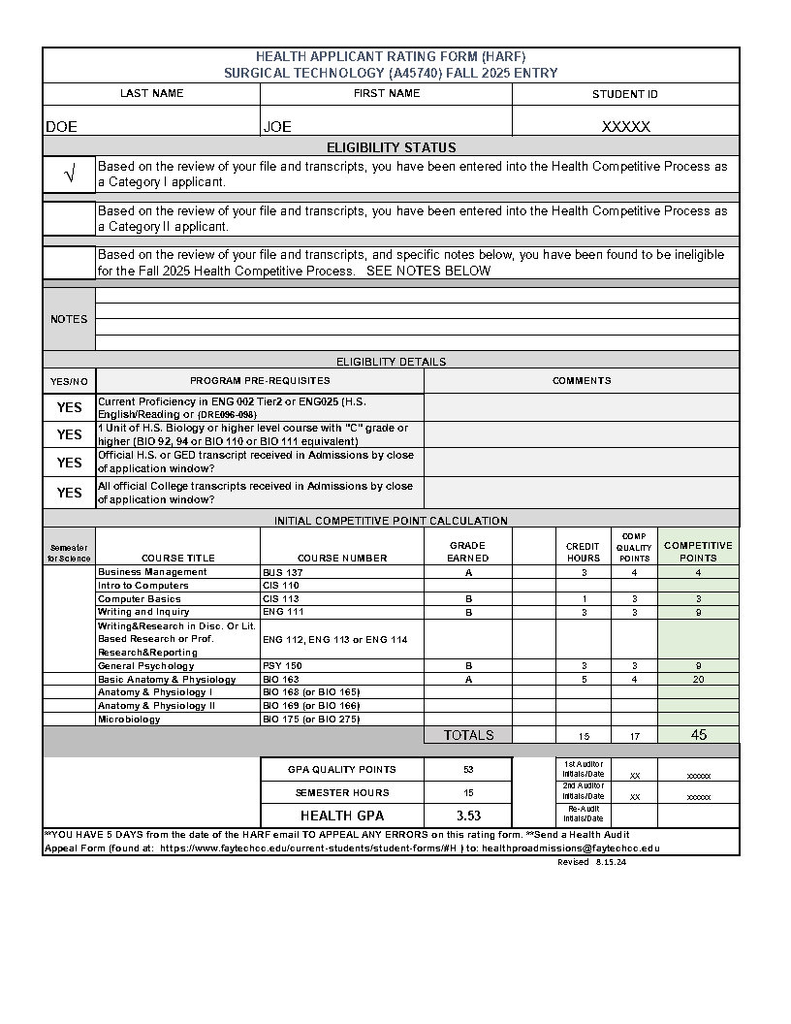

1. **HARF Appeal Process**: If applicants disagree with the information on the HARF, they will **have FIVE (5) BUSINESS DAYS** from the date the HARF was emailed to appeal that information. Applicants must complete the Health Audit Appeal Form (H-5) located in the [FTCC Student Fill In Forms website.](https://www.faytechcc.edu/current-students/student-forms/) The appeal status will be provided via Student Email within 3-5 business days.
2. If the appeal is for a transfer credit that was not awarded by the Admissions Evaluators (located in the Student Center Room 3), the student must first complete a Transfer Credit Appeal Form located on the [Student Fill In Form WebPage](https://www.faytechcc.edu/current-students/student-forms/#T) (www.faytechcc.edu/current-students/student-forms/#T) to see if Admissions will award the transfer credit before appealing the HARF points.

**PROGRAM INFORMATION SESSION**

1. Information Sessions are program specific and are normally conducted after the Health Applicant Rating forms are sent to the students notifying them of their eligibility and initial competitive points.
2. **Some programs do not hold Information Sessions**. Applicants should check with their program of interest to make sure.
3. Applicants will be notified about the Information Session by the specific health program of the date/time/location via FTCC student email.
4. Attendance is required. Applicants must contact the Department Chair for any exceptions.
5. Additional competitive points will be awarded based on departmental criteria. Additional points will be awarded at the discretion of the program. Information on additional point criteria may be found on the [program websites](https://www.faytechcc.edu/academics/healthcare-programs/). (https://www.faytechcc.edu/academics/healthcare-programs/)
6. Please note that some of our health programs have “pre-Applicant briefings” or “Advisee Information sessions” **before** the application windows open. These are separate from the required attendance Information Sessions that only “eligible” applicants will be invited to.

**FINAL CALCULATION OF COMPETITIVE POINTS**

1. After the initial competitive points are tallied, and the Health Applicant Rating Form is sent, all eligible applicants for the majority of our Health Programs are invited to a required attendance “Information Session”. This is where applicants can earn the “additional” program extra competitive points based on each program’s criteria.
2. The extra competitive points will then be added to the initial Health Applicant Rating Form (HARF) points on a Master program roster of all eligible applicants. The applicant roster will be sorted by TOTAL COMPETITIVE POINTS from Highest to Lowest. The roster will also be sorted by Health GPA and then Cumulative GPA in case of ties.
3. If the Health Program invites the eligible applicants to a **required attendance Information Session, those who do not attend are ineligible and will be removed from the competitive process unless a waiver is granted by the Department Chair.**
4. Example of Total Point Calculation:

| Source of Points | Points Awarded |
| --- | --- |
| Competitive Points from Courses on HARF | 27 points |
| Information Session Points | 30 points |
| Final Competitive Points | 57 points |

**SELECTION AND NOTIFICATION**

1. Category I applicants are placed on the Eligible Candidate list ahead of Category II applicants.
2. Applicants are listed from Highest to Lowest Points in each Category on the Eligible Candidate list for each program, then by Health GPA and then by Cumulative GPA for ties.
3. All programs have a limited number of seats.
4. The Department Chair for each program will mark the “Conditionally Selected” candidates with an “S” on the roster based on the number of seats they can fill, an “A” for Alternates, and an “NS” for Not Selected and return the roster to Health Admissions for sending of notification emails.
5. Notification emails are usually sent in late April / early May.
6. Candidates that receive a “Conditionally Selected” email must “Accept” or “Decline” their seat to finalize the selection.
   1. **Conditionally Selected candidates will normally have** **FIVE (5) BUSINESS DAYS** from the date the email was sent to submit the online Response Form. Instructions are included in the email on how to do this.
   2. Indicate “ACCEPT” or “DECLINE”
   3. A program approval email will be sent back to those applicants after they complete the Response Card.
   4. Failure to respond may result in loss of offered seat.
7. Candidates with the next highest points after those “Selected” are placed on the Alternate list. Alternates are selected if a seat becomes available and notified via email.

**KEEPING YOUR SEAT**

1. If candidates continue to take courses before entering the program, the minimum cumulative GPA and major GPA must be maintained.
2. Candidates must meet all departmental requirements such as submitting immunizations, attending orientation, etc.
3. Failure to meet any departmental requirements will result in removal from the health program listing.

**REOPENING OF HEALTH PROGRAM APPLICATION**

1. If programs do not fill to capacity, the admissions application for those programs may be reopened for a limited time.
2. Watch the FTCC website for notification on which programs have reopened.
3. If applicants previously applied to one health program and decide to apply to a re-opened program, that applicant may need to visit the Health Technology Center or may email [**healthproadmissions@faytechcc.edu**](mailto:healthproadmissions@faytechcc.edu) to request a manual application to the new program.
4. If a student applied to a re-opened program and is not eligible, the student may have time to take a course(s) to meet the eligibility requirements for the program before it closes the application again. That ineligible applicant must however, re-apply in the Health Programs Admissions office located in the Allied Health Advising Center or email [healthproadmissions@faytechcc.edu](mailto:healthproadmissions@faytechcc.edu) with their intent to re-apply based on their enrollment in the missing pre-requisite course and provide documentation that they are enrolled in the class.