# **FTCC Student Success & Engagement (SSE) - User Settings Guide**

## Overview

* Each user has individual settings to customize SSE based on duties and preferences.
* To access your settings; click on your profile picture in the top-right corner, then select Settings.

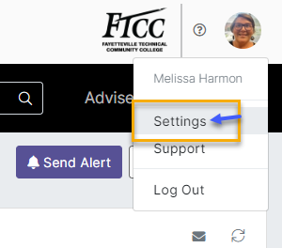

## Caseload Settings

What is a caseload?

* + Faculty Advisors (Full-time) – your assigned advisees
  + Staff & Part-time faculty do not automatically receive caseloads, but students you follow will appear on your caseload

Tip: For the most accurate view, include both current and continuing students. This will allow you to see students that are currently taking classes and those that may not but have attended within the past year.

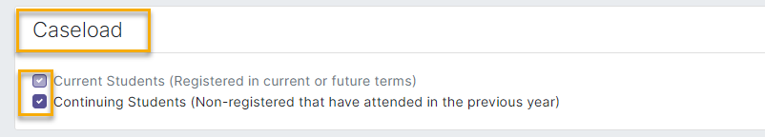

## Daily Digest Settings

Your Daily Digest email, delivered to Outlook each weekday (Monday-Friday), can be customized to show only the updates most useful to you.

### Alerts

* The alerts settings determine which **automated alerts** you want to be informed about via your news feed on the dashboard and your daily digest email.
  + If you choose alerts that are not being used, you will not receive notifications because they are not in use.
* You can choose between seeing alerts for just your “Advisees”, which are your students in your caseload, or “Advisees and Students I Follow”, which includes students not part of your caseload but you are following them.

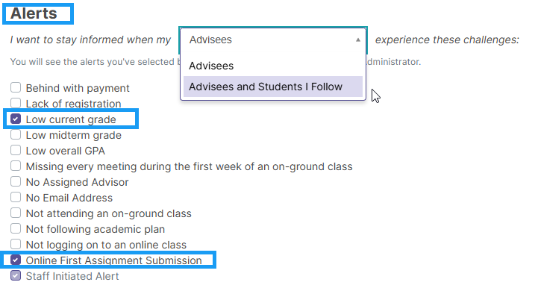

### Achievements, Events & Special Occasions

You can edit these options to your preference for your daily digest

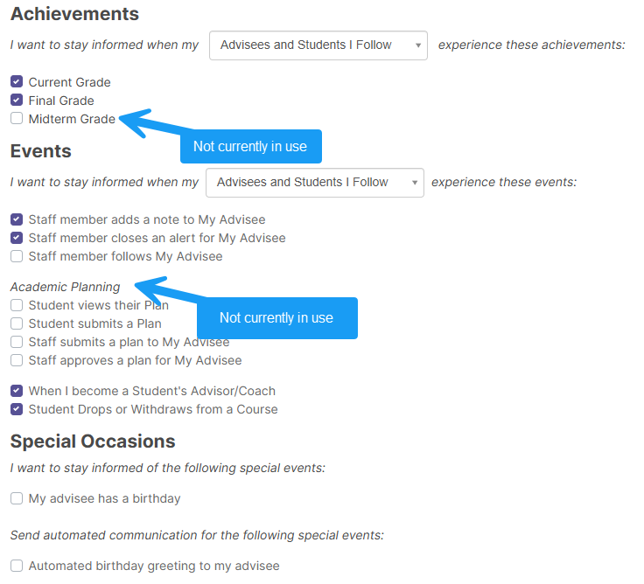

## Editing your Activity Feed

* Can adjust your activity feed to prioritize your caseload updates.
* You filter settings are automatically remembered and remain until changed.

To edit your activity feed, navigate the Student tab and then select items to bring up the menu.

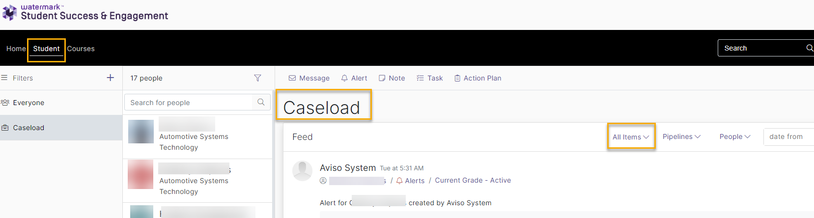

Use drop down items to edit activity feed options.

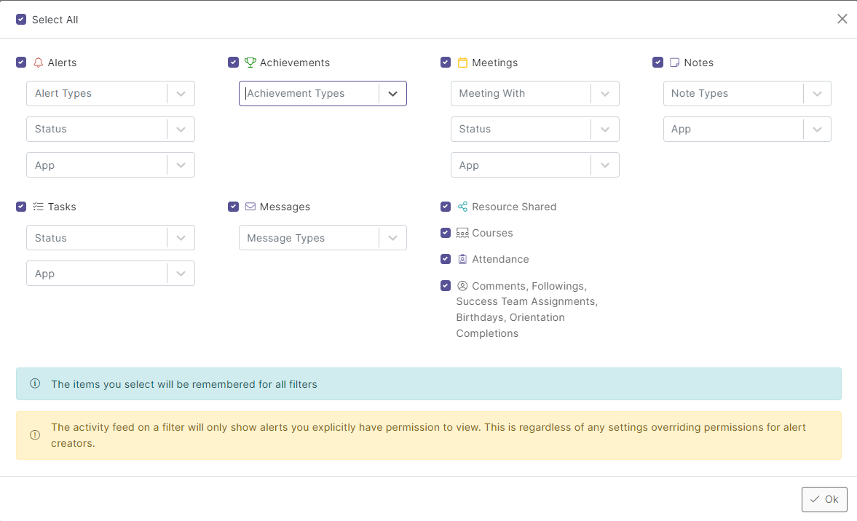

## For SSE Help or Support: Contact [SSESupport@faytechcc.edu](mailto:SSESupport@faytechcc.edu)