# **Student Success & Engagement (SSE) Quick Guide for Faculty & Staff**

## Accessing Student Success & Engagement (SSE)

* On campus à FTCC shortcuts folder à SSE link; login with your AD credentials

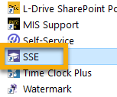

* Off campus à <https://faytechcc.avisoapp.com/> and login with your AD credentials

## For SSE Help or Support: Contact [SSESupport@faytechcc.edu](mailto:SSESupport@faytechcc.edu)

## Daily Digest

* All recent happenings with anyone on your caseload are emailed to you every morning (Monday through Friday) directly to your FTCC Outlook email. *Tip: If you do not see a daily digest email, check your “Other” folder in your Inbox. The only other time you will receive an email from SSE is when a staff-initiated (manual) alert for one of your advisees is submitted by another faculty/staff member.

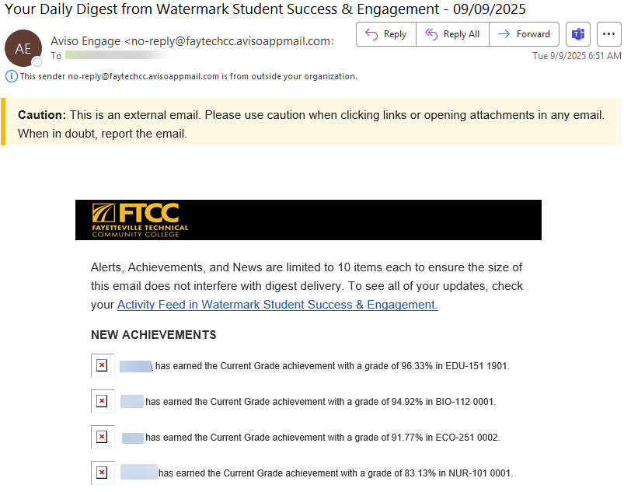

# Full-Time Faculty & Staff View

## Dashboard

* Landing page in SSE is called “My Dashboard”

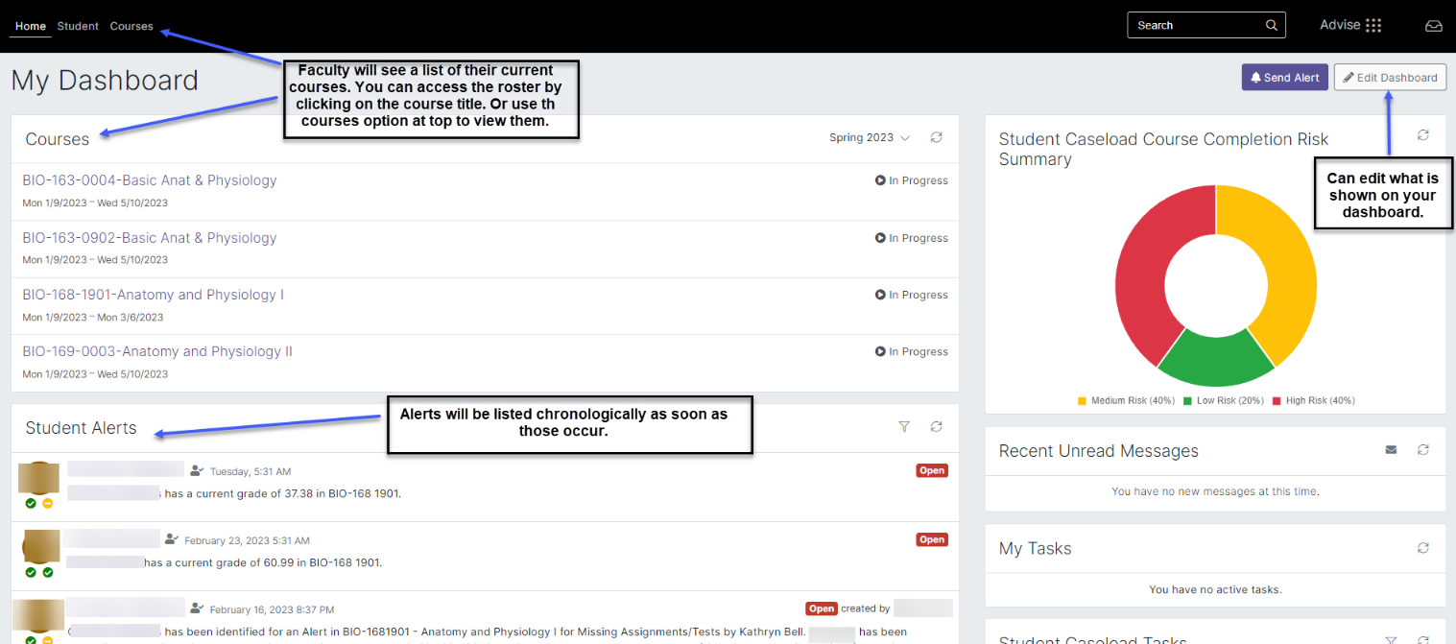

## Student Tab

* To view a student profile, select Student from the top part of your dashboard. You can search for a student using their name or ID number. Below is an example of what you will see on the student profile page

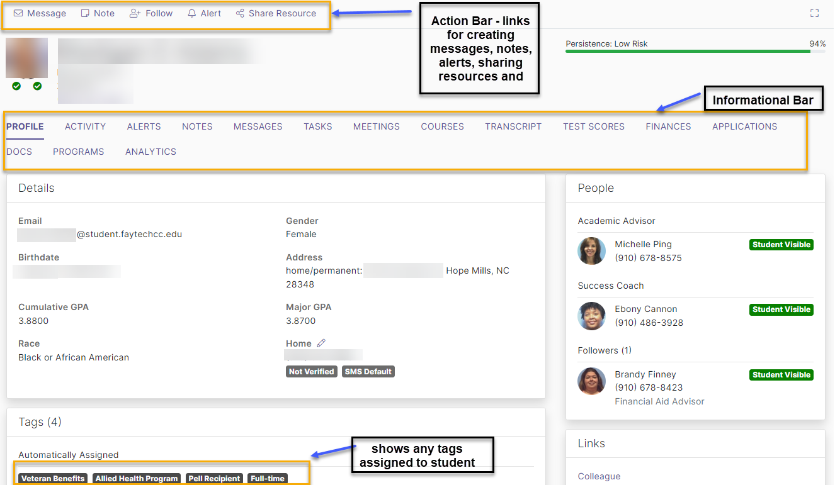

## Courses Tab View

* The courses tab allows you to view the courses the student is currently enrolled in, and you use the drop-down box to view dropped or cancelled classes. You may also go back to view previous courses.

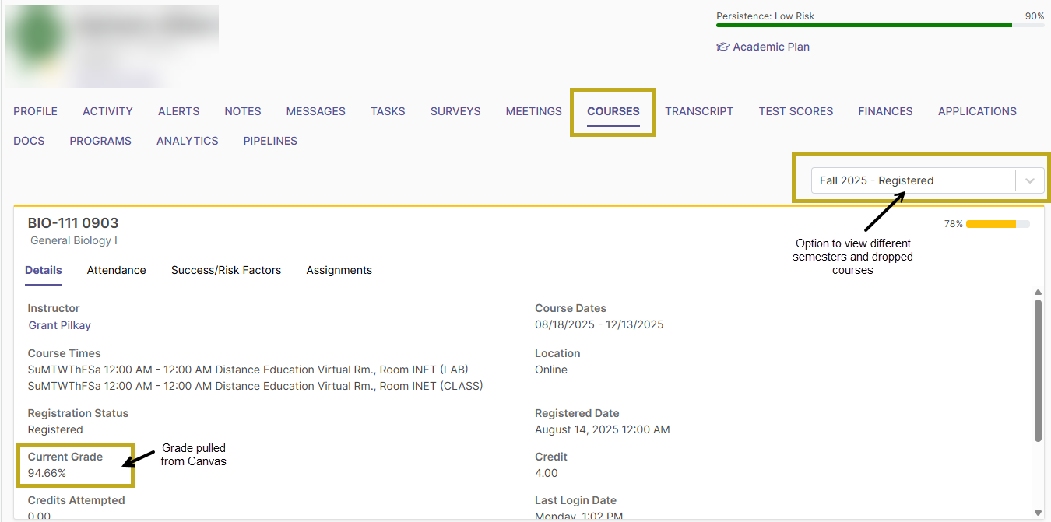

* You can also drill down on the courses to see more detailed information. The success/risk factors are unique to each student based on prior history and trends. And assignments are pulled directly from Canvas to give more data on what students may be missing for a course.

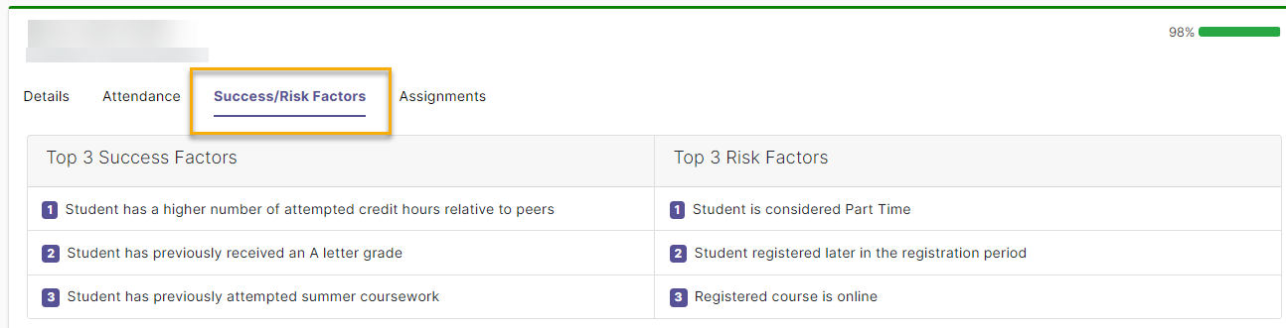

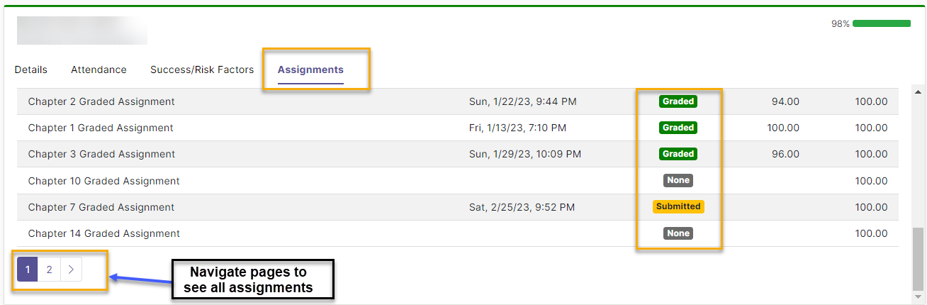

## Transcript Tab

* This tab shows student’s transcript information including course name, course credit earned, instructor’s name, and GPA. Will also show if the student has graduated or earned a credential.

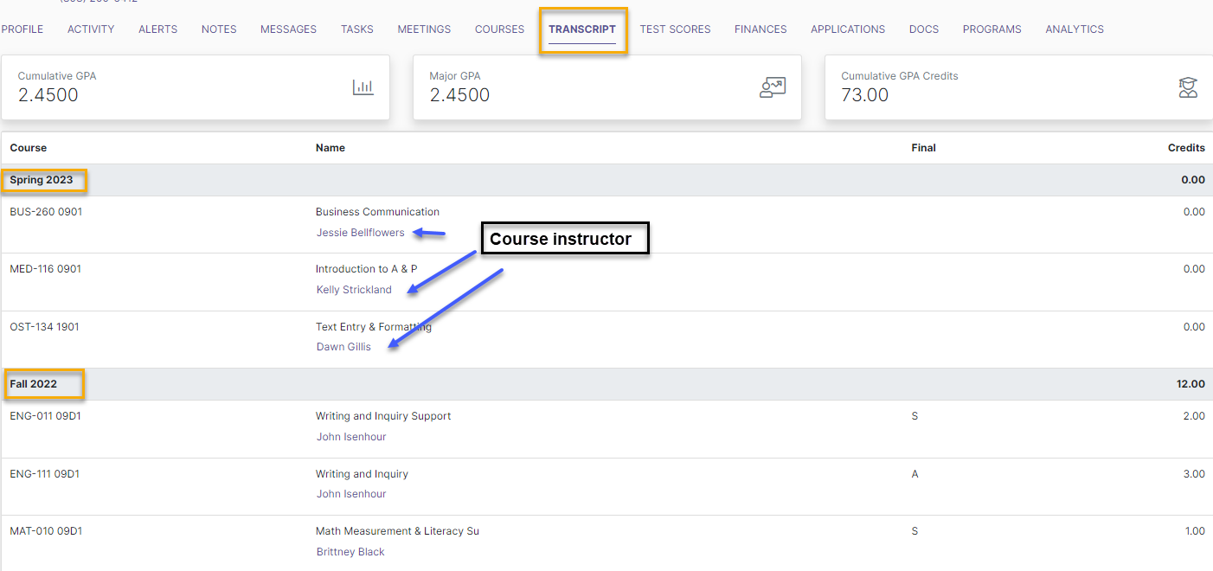

## Finances Tab

* Use this screen with ***CAUTION*** and always defer to the Financial Aid and/or Business office if you or the student have questions. This screen is to help you with supplying the best information to aid the student while advising.

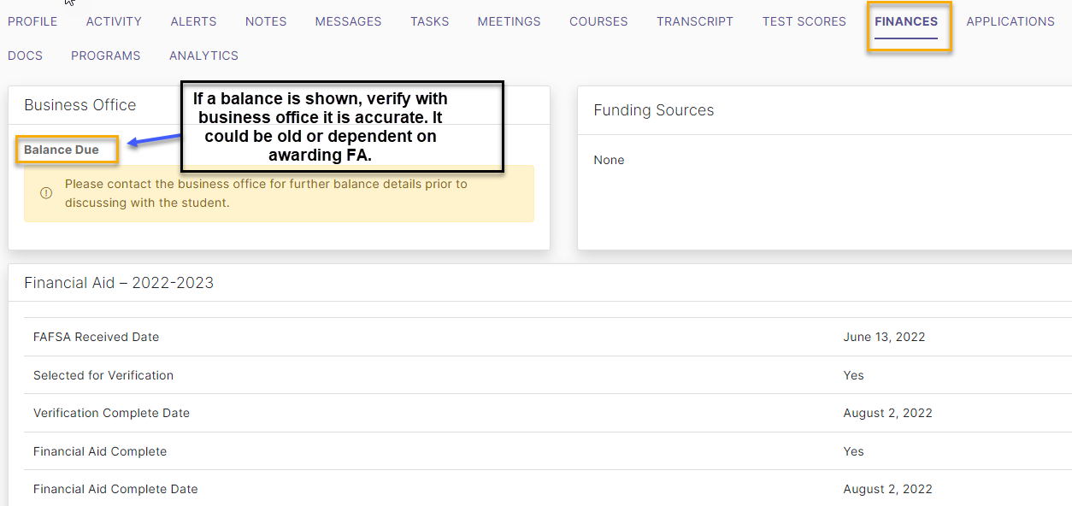

## Documents Tab

* Faculty and staff may attach a document to a student’s record.
* After attaching the document, only the user who uploaded the document may delete or change the share setting of the document.
* When the document is shared, the student can download the file.

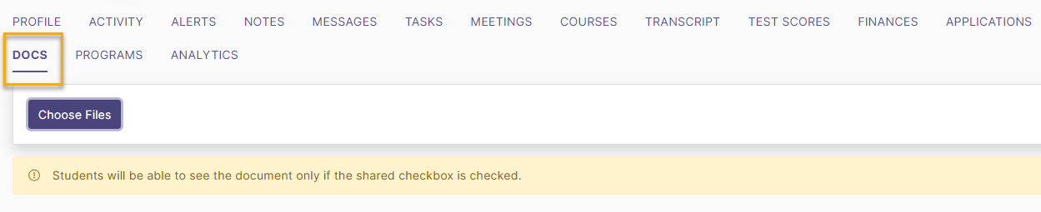

## Messages

You can access messages by selecting the icon in the upper right corner. This is your SSE inbox. Messages sent in SSE will show here, and a copy will also be sent to your Outlook email. There are options available to create scheduled messages and to create templates.

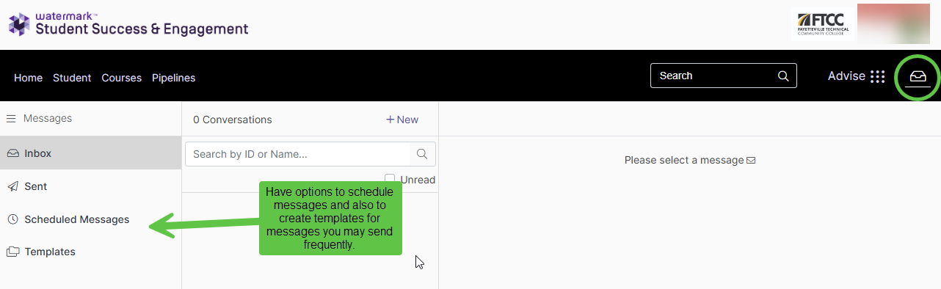

## **For SSE Help or Support: Contact** [SSESupport@faytechcc.edu](mailto:SSESupport@faytechcc.edu)

# **Part-Time Faculty View**

## Dashboard

The dashboard for part-time faculty displays less information than the dashboard for full-time faculty. This is because part-time faculty are not assigned official advisees. As a result:

* Alerts and student engagement data do not appear by default, since those are tied to assigned advisees.

However, part-time faculty still have a Student tab, which will show students in their course; as well as the Courses tab which shows their courses.

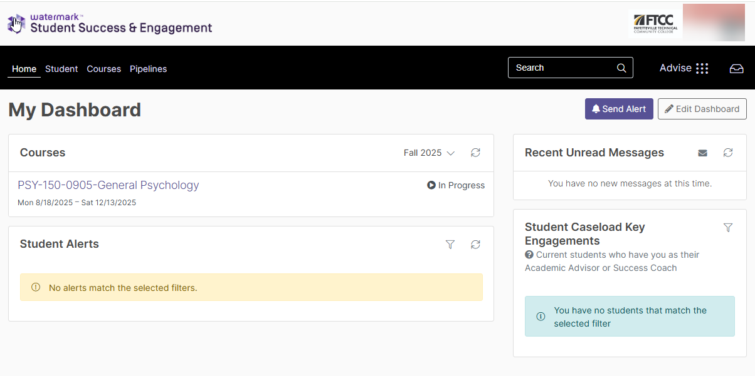

## Student Tab

On the student tab, you can view your caseload. A caseload is created by students you follow, such as the students enrolled in your course. The symbol of a person with a checkmark denotes you are following that student as shown below. You can also choose to edit the feed on your caseload to see certain information.

