# **Student Success & Engagement (SSE) – Filters Guide**

## Why Use Filters?

Filters allow you to organize and manage your caseload in SSE. They make it easy to:

* Track students with open alerts.
* Build an email list for easier communication.
* Separate active vs inactive students
* Save time

## Types of Filters in SSE

* Permanent
  + Saved to your dashboard (left-hand panel)
  + Update automatically as new students meet the criteria
* Temporary
  + Created on the spot to narrow down results
  + Disappear once you log out
  + Useful for one-time or quick tasks

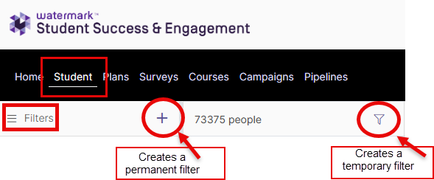

## How to Create a Filter

1. From the Student tab, click on the + icon to create a new filter.
2. Name your filter.
3. Choose your filter options.
4. Click Save. Your filter will now appear on the left-hand side panel.

## Examples of Useful Filters

### **All Assigned Advisees\***

1. Click on the + icon & name your filter
2. Add your name as advisor
3. Save filter
4. Filter saved and will be displayed on the left side of your page.

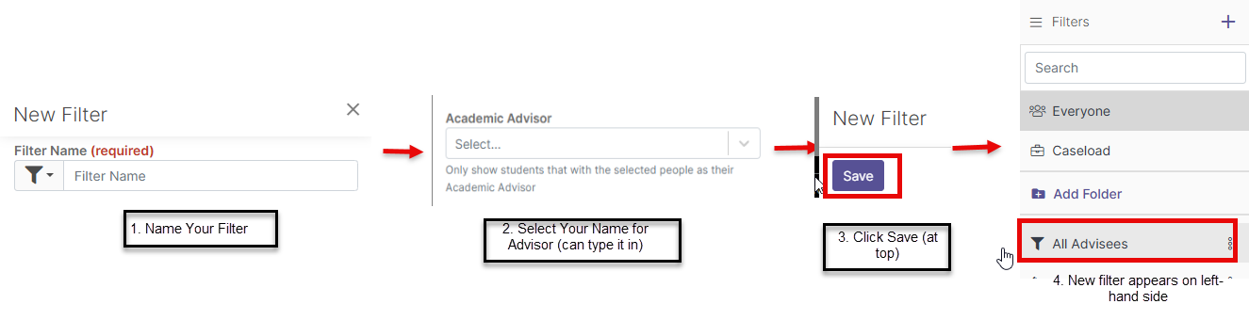

*Caseload *only* shows advisees that are registered for classes. To capture everyone assigned to you, create this filter.

### **Open Alerts for Assigned Advisees**

1. Click on the + icon and name your filter
2. Select “has open alerts” and enter your name for advisor
3. Save filter
4. Filter saved and will be displayed on the left side of your page.

(same as above, but remember to select “Has Open Alerts”)

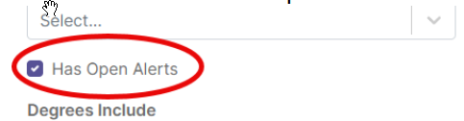

The 3 dots beside the filter will allow you to choose options for that group.

