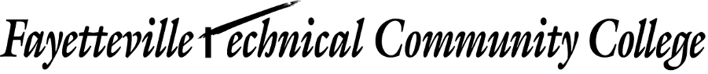

MEMORANDUM

TO: {Instructor}

FROM: {Department Chair or Program Coodrinator

DATE: {Date}

SUBJECT: Directed Studies Course

I acknowledge by signing below that the {Course/Section} course offered during the {Semester} will be a directed studies course. I will receive between .25 to 1 course load depending upon the number of students (1 to 4) in the course. The calculation will be .25 per student for a maximum 1 course load.

Signature |  | Date

Cc: {Department Chair}
{Academic Dean}

