Professional Services Agreement
(See reverse for detailed instructions on preparation)

Fayetteville Technical Community College, hereinafter referred to as the COLLEGE and
hereinafter referred to as the CONTRACTOR, enter into this agreement for professional services as described below in Item I, for the period
and the rate of pay as indicated.
- The Contractor agrees:

 |  | A. To provide professional services as follows (fully describe the services):
 |  | B. Rate of Pay: |  |  | Hourly: |  |  |  |  |  |  |  |  | Number of Hours:
 |  |  |  |  | Daily: |  |  |  |  |  |  |  |  | Number of Days:
 |  |  |  |  | Fee:
 |  | C. Period Covered: From: |  |  |  |  |  |  |  |  |  |  |  |  | To:
 |  | D. Course Title: |  |  |  |  |  |  |  |  |  |  |  |  | Number:
E Payment of all Federal and State income taxes and Social Security applicable to the compensation received
is the responsibility of the CONTRACTOR and not the COLLEGE with the following exception:
For a non-resident individual or non-resident entity (out of state) four percent (4%) NC Income Tax will
be withheld unless a certificate of authority is presented.
F. The rate of pay specified above includes all expenses of the CONTRACTOR including travel and
sustenance.
G. CONTRACTOR agrees that this agreement may be terminated by the COLLEGE either due to cause
or cancellation of the course due to lack of students or funds.
- The COLLEGE agrees to make payment upon completion of services rendered as provided in Items I, A above, upon
receipt of a completed invoice submitted in duplicate itemizing services furnished and certified to by the responsible
Dean and/or Director.
- The attached Terms and Conditions are hereby incorporated by reference into this Professional Service Agreement as if fully set forth herein.
- ATTEST:
 | A. CONTRACTOR:
 | Address:
 | Phone #:
 | Please check one: |  |  |  | Individual Proprietor Corporation Non-Profit Other
 | If out of state, please check one: 4% NC income tax withheld Certificate of authority attached
 | CONTRACTORS FED. ID NO.  If a social security number is used the Independent Contractor questionnaire must be filled out. |  |  |  |  |  |  |  | NAME PRINTED |  |  |  |  |  |  | SIGNATURE |  |  |  |  |  | DATE
 | B. COLLEGE:
 | 1. Dean/Director:
 |  |  | NAME PRINTED |  |  |  |  |  | SIGNATURE |  |  |  |  |  |  |  |  |  | DATE
 | 2. Funds in the amount of $ |  |  |  |  |  |  |  |  |  | are available and have been obligated for payment of this agreement.
 | Code Chargeable:
 | SIGNATURE – PRESIDENT/CHIEF FINANCIAL OFFICER |  |  |  |  |  |  |  |  |  |  |  |  |  |  |  |  |  | DATE
- Please complete the attached W-9 and submit with the PSA. Payment is subject to 28% backup withholding if W-9 is not received. Contact information on W-9 and PSA must agree.

Importance Notice: This form must not be used for services of an employee of the College. An employee is defined as one who
performs services subject to the will and control of the College as to what shall be done and how it shall be done.
FORM ADM11801

FAYETTEVILLE TECHNICAL COMMUNITY COLLEGE
SERVICE AGREEMENT TERMS AND CONDITIONS

1. GOVERNING LAW AND VENUE: This Service Agreement is made under and shall be governed and construed in accordance with the laws of the State of North Carolina. All actions and suits arising out of the performance or non-performance of this Service Agreement shall be brought forward exclusively in the State Courts of Cumberland County, North Carolina. Accordingly, the Parties submit to the personal jurisdiction of the State Courts of North Carolina.

2. INDEPENDENT CONTRACTOR: The Contractor shall be considered to be an independent contractor and as such shall be wholly responsible for the work to be performed and for the supervision of its employees. The Contractor represents that it has, or will secure at its own expense, all personnel required in performing the services under this agreement. Such employees shall not be employees of, or have any individual contractual relationship with Fayetteville Technical Community College (hereinafter “College”).

3. KEY PERSONNEL: The Contractor shall not substitute key personnel assigned to the performance of this Service Agreement without prior written approval of the College. The individuals designated as key personnel for purposes of this Service Agreement, if any, are those specified in the Service Agreement or the Contractor's proposal.

4. INTELLECTUAL PROPERTY: Any Intellectual Property created by the Contractor pursuant to this Service Agreement and delivered to the College in fulfillment of the Contractor’s contractual obligations to the College pursuant to this Service Agreement shall be deemed to be “Work for Hire” and said intellectual property shall be wholly and solely owned by the College. If the Contractor delivers to the College any intellectual property not created pursuant to this Service Agreement, the Contractor shall secure and deliver to the College, at the Contractor’s own expense, any and all necessary licenses for the College’s reasonable use of said intellectual property. Failure to render said licenses shall be deemed to be a default by the Contractor and the College shall be permitted to pursue all remedies available to it against the Contractor.

5. SUBCONTRACTING/ ASSIGNMENT: The Contractor shall not subcontract any work to be performed under this Service Agreement without prior written approval of the College. The Contractor shall not assign the Contractor’s obligations or rights under this Service Agreement without the prior written approval of the College.

6. PERFORMANCE AND DEFAULT: If, through any cause, the Contractor shall fail to fulfill in timely and proper manner the obligations under this Service Agreement, the College shall thereupon have the right to terminate this Service Agreement after giving written notice to the Contractor specifying the defect and providing a reasonable time for the Contractor to cure defect. Upon termination, all finished or unfinished deliverable items under this Service Agreement prepared by the Contractor shall, at the option of the College, become its property, and the Contractor shall be entitled to receive just and equitable compensation for any satisfactory work completed on such materials. Notwithstanding, the Contractor shall not be relieved of liability to the College for damages sustained by the College by virtue of any default on or breach of this agreement, and the College may withhold any payment due the Contractor for the purpose of setoff until such time as the exact amount of damages due the College from such breach can be determined. In case of default by the Contractor, the College may procure the services from other sources and hold the Contractor responsible for any excess cost occasioned thereby. Neither party shall be deemed to be in default of its obligations hereunder if and so long as it is prevented from performing such obligations by any act of war, hostile foreign action, nuclear explosion, riot, strike, civil insurrection, earthquake, hurricane, tornado, or other catastrophic natural event or act of God.

7. AMENDMENTS: This Service Agreement may be amended only by written amendments duly executed by the College and the Contractor.

8. AVAILABILITY OF FUNDS: The College is largely dependent upon appropriation and allocation of funds by the State of North Carolina and Cumberland County. At the time the College enters this Service Agreement, the College reasonably believes that funds will be made available to it to fulfill its obligations under this contract. However, if funds are not appropriated, allocated, or otherwise provided to the College in amounts which the College reasonably believes are sufficient to fulfill its obligations, the College, in its sole discretion may immediately terminate this contract.

9. CONFIDENTIALITY: Each party agrees to notify the other party in writing of any information provided pursuant to this service agreement which qualifies as confidential information, as defined by N.C. General Statute § 132-1.2. Such information shall be kept confidential and shall not be divulged or made available to any individual or organization without the written approval of the party deeming the information confidential. Notwithstanding the forgoing, if legal action is brought against the College under the North Carolina Public Records Law (N.C. Gen. Stat. § 132.1 et. seq.) seeking the release of any information designated as confidential by the Contractor, the Contractor shall permit the release of the information or intervene in the legal action and bear the reasonable costs of litigation associated with maintaining the confidential nature of the information.

10. ADVERTISING/PRESS RELEASE: The Contractor shall not publicly disseminate any information concerning the Service Agreement without prior written approval of the College.

11. ACCESS TO PERSONS AND RECORDS: The Contractor agrees to maintain all pertinent documents and records relating to this Service Agreement for five (5) years following completion of the Service Agreement period. The Contractor acknowledges the right of the College and the State Auditor to audit all records related to any transaction related to the performance of this Service Agreement.

- COMPLIANCE WITH LAWS: The Parties shall comply with all laws, ordinances, codes, rules, regulations, and licensing requirements that are applicable to the conduct of its business, including those of federal, state, and local agencies having jurisdiction and/or authority.

- AFFIRMATIVE ACTION: The Parties shall take affirmative action in complying with all Federal and State requirements concerning fair employment and employment of the handicapped, and concerning the treatment of all employees without regard to discrimination by reason of race, color, religion, sex, national origin, or physical handicap.

- ENTIRE AGREEMENT: This Service Agreement and any documents incorporated specifically by reference represent the entire agreement between the parties and supersede all prior oral or written statements or agreements. All promises, requirements, terms, conditions, provisions, representations, guarantees, and warranties contained herein shall survive the Service Agreement expiration or termination date unless specifically provided otherwise herein, or unless superseded by applicable Federal or State statutes of limitation.

- ORDER OF PRECEDENCE: To the extent of contradictory terms between these Terms and Conditions and any other part of this Service Agreement or Contract, these Terms and Conditions shall prevail, except that specific agreements as to the ownership of intellectual property shall prevail over paragraph 4. of these Terms and Conditions.

- INDEMNITY: The College does not indemnify and/or hold harmless the Contractor for any purpose if such indemnification and/or hold harmless provision is inconsistent with the College’s statutory authority to waive Sovereign Immunity.

- INTEREST ON LATE PAYMENTS: The College shall make every reasonable effort to remit payment as required by this Service Agreement within thirty (30) days of its receipt of an invoice from the Contractor, if services have been fully rendered. However, the College shall not be held responsible for any late fees or interest resulting from delays in its remitting payment to the Contractor.

INSTRUCTION FOR PREPARATION

- This form will be used in contracting for professional services with any individual, private company, or governmental agency.

- The appropriate dean, director, coordinator or other supervisor contracting for professional services will prepare this agreement in duplicate and forward both copies to the Office of Business and Finance. Items I thru IV will be completed prior to forwarding to the Office of Business and Finance.

- Item I, A must be completed fully, describing all services to be furnished, including any supplies and required reports.

- The rate of pay specified in item I, B includes all expenses of the contractor, including travel and subsistence.

- Official Course Number must be entered in Item I, D for Continuing Education Courses.

- Contractor’s federal identification number must be entered in the appropriate space in Section IV, A. All companies or business required to report employment taxes or give tax statements to employees are required to have a federal identification number. This is normally a (9) digit number starting with “56” and is listed as “56-XXXXXXX”.

- To obtain certificate of authority: write Secretary of State, Corporation Division, 300 N. Salisbury Street, Raleigh, NC 27603-5909 or fax a form request to (919) 733-1837. Persons with INTERNET access may download the form from the Secretary of State’s website, http://www.state.nc.us/secstate/.

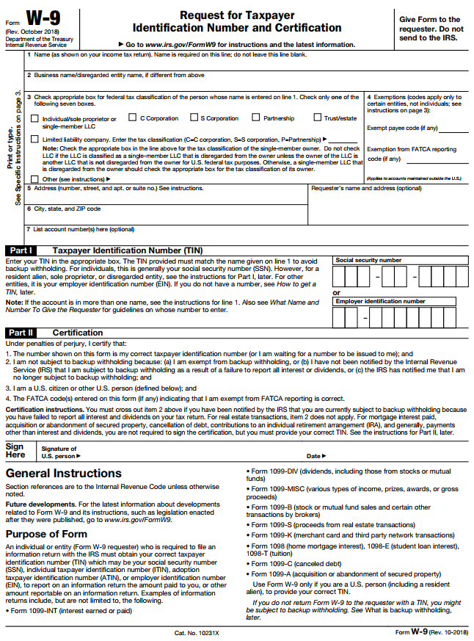
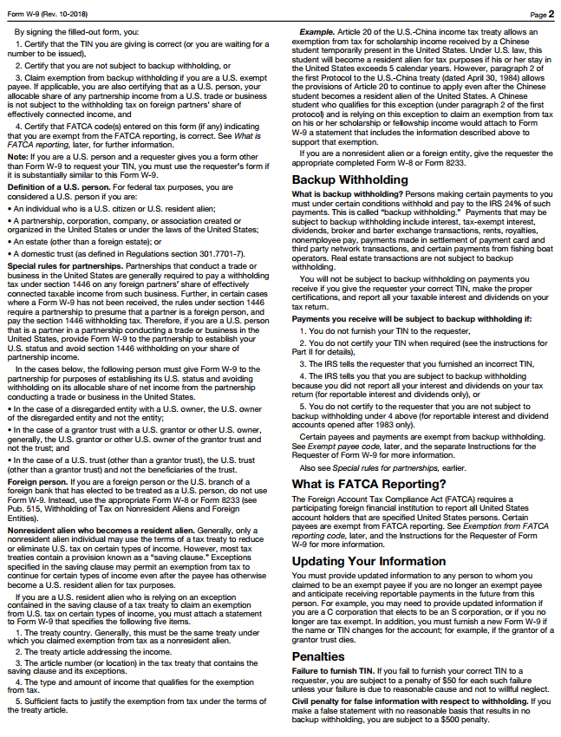

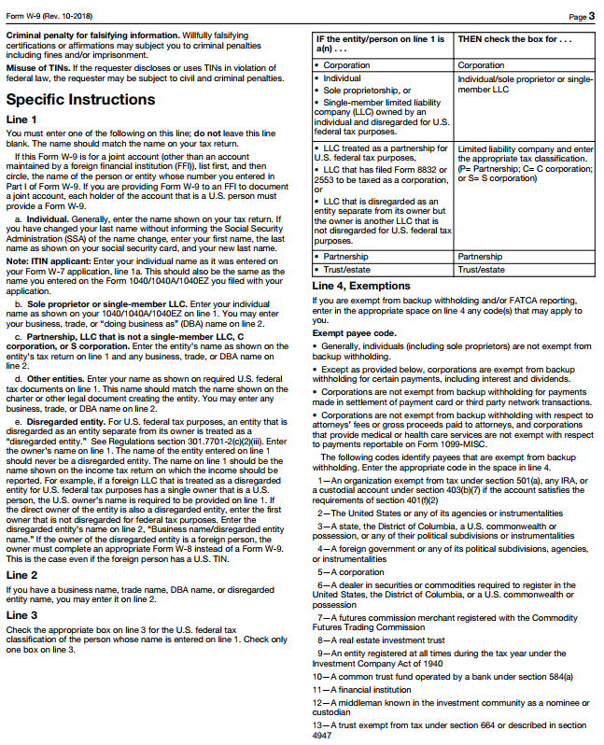

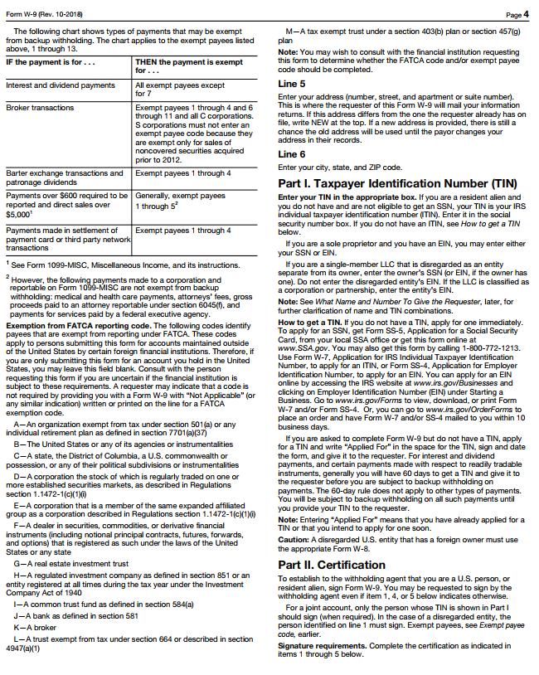

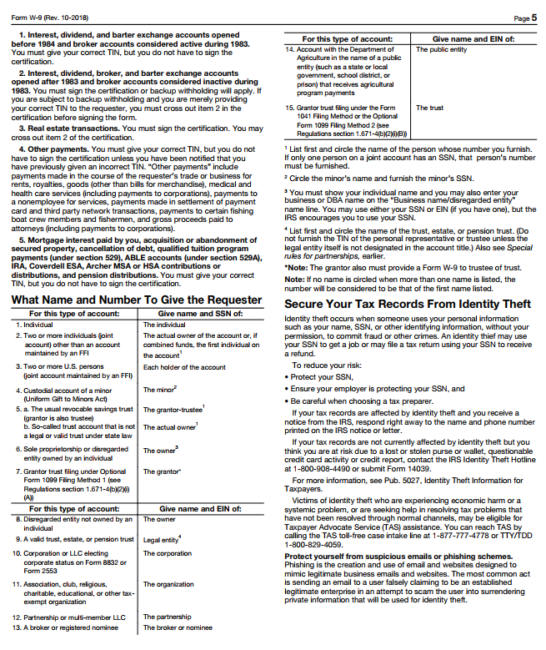

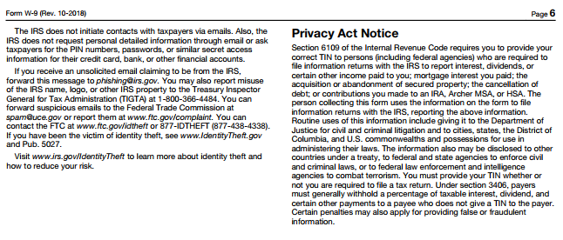
INDEPENDENT CONTRACTOR QUESTIONNAIRE
(TO BE FILLED OUT BY POTENTIAL CONTRACTOR)

This questionnaire must be completed to determine if an individual is eligible to be an independent contractor and must be submitted to the Office of Business and Finance before any service is performed.

All available information will be evaluated in the determination of status. You will be notified of the
determination. If it is determined that you qualify as an independent contractor, a purchase order will be issued to you and an invoice must be submitted to Accounts Payable after the work is completed.
All approved contractors must be registered with the state’s e-procurement system and complete a FTCC vendor registration form. If it is determined that you should be paid as an employee, please work with the hiring department to submit the required documentation through our usual HR/payroll process before work commences.

Please provide the following information making additional comments as appropriate:

Name/Business Name:

Social Security Number or Federal Identification Number

Business License Number Issued by

Type of Entity: Individual Sole Proprietor Partnership LLC Corporation

Business Address:

Business Phone and Fax Number:

Brief description of services to be performed:

Period when services are to be performed

Amount to be paid for services

Are you a U.S. Citizen, Permanent Resident or Non-Resident Alien?
(If Non-Resident Alien, you must also complete the Foreign National Information System Data Gathering Form)

Yes No Have you ever been or are you currently an employee or student-employee
of FTCC?

Yes No Have you ever been or are you currently employed by any other agency
of the State of NC or another NC community college? If yes, list agency
or college and dates of employment.

INDEPENDENT CONTRACTOR QUESTIONNAIRE
(TO BE FILLED OUT BY POTENTIAL CONTRACTOR)

Yes No Have you performed services as an Independent Contractor for other
employers?

If yes, list the three most recent:

Name of Company Dates

Yes No Do you have employees?
If yes, provide your Workers’ Compensation Insurance Carrier Name:

Yes No If you have employees, have you paid federal and state payroll taxes for
your employees?

Yes No If you use subcontractors in your business, do you issue IRS Form 1099’s
to them for their services to report their income?

Yes No Do you have general liability insurance?

Please list your carrier:

Yes No NA If you are a sole proprietor, do you file a Schedule C and pay self employment
taxes on your income?

Yes No Will you furnish the tools, materials, equipment and supplies needed to
perform the services?

If yes, provide description of items furnished:

Yes No Do you advertise your services? Where?
If you don’t advertise, how do you market your services?

Yes No Is there any other information that would support treatment of you as an
independent contractor? Please describe.

I affirm the above are true statements.

Signature Date

STATEMENT OF PURPOSE: The information on this form is being gathered to determine the
status of an individual for employment taxes and income tax withholding.

INDEPENDENT CONTRACTOR QUESTIONNAIRE
(TO BE COMPLETED BY FTCC PERSONNEL)

This questionnaire must be completed to determine if an individual is eligible to be an independent contractor and must be submitted to the Office of Business and Finance with a Scope of Work and the Professional Services Agreement before any service is performed.

In addition to this questionnaire, the Scope of Work, PSA and the forms to be completed by the potential contractor will all be evaluated in the determination of status. You will be notified of the determination. If it is determined that the individual qualifies as an independent contractor, a purchase order will be issued to the independent contractor and an invoice can be submitted to Accounts Payable after the work is completed. If it is determined that the individual should be paid as an employee, please prepare the required paperwork to have the individual’s payment processed through Payroll before work commences.

Please provide the following information concerning the individual you are considering hiring making additional comments as appropriate:

Name of the individual/business:

Social Security Number or Federal Identification Number

Business License Number Issued by

Type of Entity: Individual Sole Proprietor Partnership LLC Corporation

Business Address:

Brief description of services to be performed (attach a Scope of Work):

Period when services are to be performed

Amount to be paid for services

Is the individual a U.S. Citizen, Permanent Resident or Non-Resident Alien?

(If Non-Resident Alien, individual must also complete the Foreign National Information System Data Gathering Form)

Yes No Has this individual ever been an employee or student-employee of FTCC?

Yes No Is this individual currently working for any other agency of the State of NC?

INDEPENDENT CONTRACTOR QUESTIONNAIRE
(TO BE COMPLETED BY FTCC PERSONNEL)

If the answers to both employment questions are “no”, continue survey. Otherwise sign survey and submit to Finance with attachments.

Yes No Is the individual working exclusively for FTCC?

Yes No May this individual designate another to perform the services?

Yes No Are the services of the individual integrated into your department? For
example, are you hiring someone to teach a course?

Yes No If this individual is teaching a class, are they listed as the instructor in the
class schedule/course catalog?

Yes No Will this individual hire, supervise and pay other workers to perform the
service?

Yes No Does FTCC provide on-going training and direction concerning how to
complete the task? Are you giving more than general directions and the
objective of the task?

Yes No Is there a regular or on-going relationship with the individual? Have you
hired this individual in the past?

Yes No Does the individual have a place of business other than his/her home?

Yes No Will this individual be able or need to perform some of the services at a
business location he/she provides?

Yes No Will the individual perform all work at FTCC-designated locations?

Yes No Will the individual determine his/her hours of work?

Yes No Will FTCC reimburse the individual for any expenses incurred while
performing these services?

Yes No Will FTCC furnish the individual with the tools, materials, equipment and
supplies needed to perform the services?

Yes No Will the individual be paid on a lump sum basis?

Yes No Can the individual quit prior to the completion of the project without
penalty?

Yes No Is there any other information which would support treatment of the
individual as an independent contractor? Please describe below.

CERTIFICATION OF HIRING MANAGER:

I certify that I have completed this form to the best of my knowledge and
have attached the Scope of Work and Professional Services Agreement
as required prior to any work being performed by the potential contractor.

Signature Date

Printed Name and email address

Department

DO NOT WRITE BELOW THIS LINE – FOR FINANCE USE ONLY

Status Determination: Independent Contractor

Employee

Determination sent to hiring manager via email on
(Date)

Signature Date

Printed Name

Department

STATEMENT OF PURPOSE: The information on this form is being gathered to determine the
status of an individual for employment taxes and income tax withholding.

