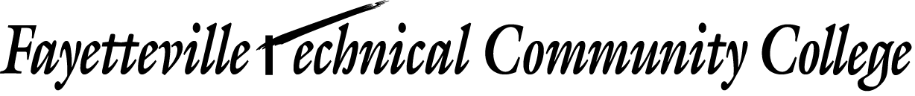
Learning Technologies Division - Media Services Group

Model Release

For and in consideration of my engagement as a model by Fayetteville Technical Community College, hereafter referred to as the photographing agency, at no charge to the photographing agency or its representatives or agents, I hereby grant to the photographing agency the right and permission to copyright and/or use, reuse and/or publish, and republish photographic pictures or portraits of me, or in which I may be distorted in character, or form, in conjunction with my own or a fictitious name, on reproductions there of in color, or black and white made through any media by the photographing agency in its studio or elsewhere, for any purpose whatsoever; including the use of any printed matter in conjunction therewith.

I hereby waive any right to inspect or approve the finished photographic image or advertising copy or printed matter that may be used in conjunction therewith or to the eventual use that it might be applied.

I hereby release, discharge and agree to save harmless the photographing agency, its representatives or agents, including any firm publishing and/or distributing the finished product, in whole or in part, from and against any liability as a result of any distortion, blurring, or alteration, optical illusion, or use in composite form, either intentionally or otherwise, that may occur or be produced in the taking, processing or reproduction of the finished product, its publication or distribution of the same, even should the same subject me to ridicule, scandal, reproach scorn or indignity.

I hereby warrant that I am under/over (circle one) eighteen years of age, and competent to contract in my own name in so far as the above is concerned.

I am not being compensated in any way either financially or otherwise. I am agreeing to participate in this photographic opportunity totally as a volunteer.

I have read the foregoing release, authorization and agreement before affixing my signature below, and warrant that I fully understand the contents thereof.
Name |  |  |  |  |  |  |  | Date
Name printed
I hereby certify that I am the parent and/or guardian of |  |  |  |  |  |  | , a child under the age of
eighteen years, and hereby consent that any photographs which have been or are about to be taken for the
photographing agency may be used by them for the purposes set forth in the release as listed above.

Parent or Guardian |  |  |  |  | Date
Name Printed
Name of Child

