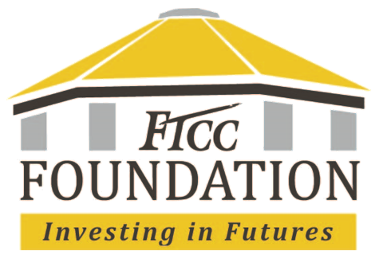

Gift-in-Kind Donations:
Donation Process

- FTCC Department receives notice or intent of donation from donor. Anyone may donate either directly or by contacting a department.
- FTCC Department alerts FTCC Foundation of donation intent through e-mail: foundation@faytechcc.edu or by phone x88441.
- The donor will need to complete a gift in kind (GIK) form.
- Delivery must be coordinated AFTER the GIK form has been completed and received.
- The donor will receive a tax receipt for the donation for that year’s tax purposes.

