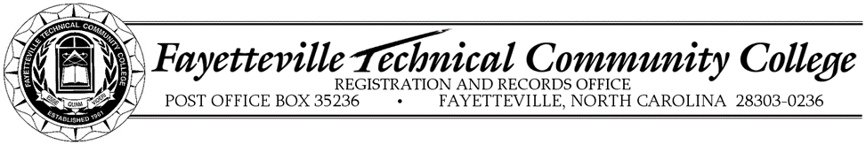
CONSENT FOR RELEASE OF STUDENT INFORMATION FOR EDUCATION RECORD
The Family Educational Rights and Privacy Act (FERPA) of 1974 is a federal law that protects the confidential nature students’ educational records. (Educational records are records such as academic records, attendance records, disciplinary records, and financial records.) FERPA requires Fayetteville Technical Community College to protect students’ educational records from disclosure, even to one’s parents, except in some limited circumstances defined by federal law. However, a student may authorize the release of their own educational records by completing this form. (Complete information on FERPA rights can be found in the FTCC Student Handbook.)
In accordance with the Federal Education Rights and Privacy Act, the undersigned authorizes Fayetteville Technical Community College to release my confidential educational records to the individuals named below. This consent is effective as of this date and for one year, unless revoked sooner, in writing, to the Registrar’s Office.
Name |  |  | Relationship
Name |  |  | Relationship
Name |  |  | Relationship
*Individuals listed above must present a picture identification card to obtain information.
The following FTCC departments are included in this release and all records for each department may be shared with persons listed above. For student athletes, this also includes all athletic department personnel, including coaches and the Athletic Director.
Check all that apply (Athletes must check all boxes):
 | Admissions and Counseling |  |  | Student Accounts and Bookstore
 | Financial Aid |  |  | Student Learning Center
 | Registration and Records

Student Name (printed) |  | Student Signature
Student ID Number |  | Date
Received by FTCC Employee Signature |  | Date

Submit this form to the Registrar’s Office, Tony Rand Student Center, Room 124
Email registrar@faytechcc.edu.

